July 22, 2024
BLE Mesh based IR AC Controller
Software Design Document
Table of Contents
1 Introduction 6
2 Purpose of Document 6
3 Product Brief 6
4 Software Architecture 6
5 Basics and Terminologies 7
5.1 MQTT Broker 7
5.2 Gateway 7
5.3 Registration 7
5.4 Unregistration 7
5.5 Node 7
5.6 Provisioning 7
5.7 Unprovisioning 7
5.8 AC Remote Configuration 8
5.9 Teaching Mode 8
5.10 List of AC Brands Supported by Gwy/Node 9
5.11 MQTT Publishing 9
5.12 MQTT Subscribing 9
6 Gateway LED Indications 9
7 Node LED Indications 10
8 Gateway Button Press Logics 10
9 Node Button Press Logics 11
10 MQTT Communication Packets 11
10.1 Error codes 12
10.1.1 FAILURE 14
10.1.2 SUCCESS 14
10.1.3 JSON_PACKET_ID_NOT_FOUND 14
10.1.4 JSON_PACKET_ID_UNKNOWN 14
10.1.5 MSG_SEQ_NO_NOT_FOUND 14
10.1.6 GWY_SER_NO_NOT_FOUND 15
10.1.7 GWY_SER_NO_INVALID 15
10.1.8 LOCATION_NOT_FOUND 15
10.1.9 LOCATION_EXCEEDING_RANGE 15
10.1.10 NODE_COMM_TIMEOUT 15
10.1.11 GWY_NOT_REG 15
10.1.12 GWY_ALREADY_REG 15
10.1.13 MAC_ID_NOT_FOUND 16
10.1.14 MAC_ID_CONTAINS_INVALID_CHARS_OR_INVALID_FORMAT 16
10.1.15 INVALID_MAC_ID_LENGTH 16
10.1.16 NODE_SER_NO_NOT_FOUND 16
10.1.17 ELEMENT_ADDR_NOT_FOUND 16
10.1.18 GWY_NOT_CONFIGURED_WITH_AC_REMOTE 16
10.1.19 NODE_NOT_CONFIGURED_WITH_AC_REMOTE 16
10.1.20 POWER_NOT_FOUND 16
10.1.21 POWER_EXCEEDING_RANGE 17
10.1.22 MODE_NOT_FOUND 17
10.1.23 MODE_EXCEEDING_RANGE 17
10.1.24 FAN_SPEED_NOT_FOUND 17
10.1.25 FANSPEED_EXCEEDING_RANGE 17
10.1.26 TEMPERATURE_NOT_FOUND 17
10.1.27 TEMPERATURE_EXCEEDING_RANGE 17
10.1.28 SWING_H_NOT_FOUND 17
10.1.29 SWING_H_EXCEEDING_RANGE 18
10.1.30 SWING_V_NOT_FOUND 18
10.1.31 SWING_V_EXCEEDING_RANGE 18
10.1.32 ONTIMER_NOT_FOUND 18
10.1.33 ONTIMER_EXCEEDING_RANGE 18
10.1.34 OFFTIMER_NOT_FOUND 18
10.1.35 OFFTIMER_EXCEEDING_RANGE 18
10.1.36 LOCKING_NOT_FOUND 18
10.1.37 LOCKING_EXCEEDING_RANGE 18
10.1.38 TEMP_LOCK_UP_LIMIT_NOT_FOUND 18
10.1.39 TEMP_LOCK_LOW_LIMIT_NOT_FOUND 19
10.1.40 TEMP_LOCK_UP_LIMIT_EXCEEDS_ABS_TEMP_UP_LIMIT 19
10.1.41 TEMP_LOCK_LOW_LIMIT_EXCEEDS_ABS_TEMP_LOW_LIMIT 19
10.1.42 ILLOGICAL_LOCKING_TEMP_LIMIT 19
10.1.43 PUBLISH_PERIOD_NOT_FOUND 19
10.1.44 PUBLISH_PERIOD_EXCEEDS_RANGE 19
10.1.45 MSG_SEQ_NO_EXCEEDING_RANGE 19
10.1.46 NODE_SER_NO_INVALID 19
10.1.47 RESET_DEVICE_NOT_FOUND 19
10.1.48 LOGGING_FLAG_NOT_FOUND 20
10.1.49 FORBIDDEN_OPERATION 20
10.1.50 UNKNOWN ERROR CODE 20
10.1.51 AC_REMOTE_UNSUPPORTED 20
10.1.52 JSON_PACKET_INVALID 20
10.2 Common JSON parameters 20
10.3 Gateway Registration Packet 21
10.4 Gateway Registration ACK 22
10.5 Gateway AC Remote Configuration ACK 23
10.6 Gateway Unregistration Packet 24
10.7 Gateway Unregistration ACK 25
10.8 Gateway AC Control Packet 26
10.9 Gateway AC Control ACK 27
10.10 Gateway AC Manual control ACK 29
10.11 Gateway AC Remote Reconfiguration Packet 31
10.12 Gateway AC Remote Reconfiguration ACK 32
10.13 Gateway Heartbeat ACK 33
10.14 Gateway Heartbeat Publish Configuration Packet 34
10.15 Gateway Heartbeat Publish Configuration ACK 35
10.16 Gateway Teaching Mode Start Packet 36
10.17 Gateway Teaching Mode Start ACK 38
10.18 Gateway Teaching Mode End ACK 39
10.19 Gateway Debug Info Packet (Only for QMAX Internal use) 40
10.20 Gateway Debug Info ACK (Only for QMAX Internal use) 41
10.21 Node Provision Packet 42
10.22 Node Provision ACK 43
10.23 Node AC Remote Configuration ACK 44
10.24 Node Unprovision Packet 45
10.25 Node Unprovision ACK 46
10.26 Node AC Control Packet 47
10.27 Node AC Control ACK 49
10.28 Node AC Manual control ACK 50
10.29 Node AC Remote Reconfiguration Packet 52
10.30 Node AC Remote Reconfiguration ACK 53
10.31 Node Heartbeat ACK 54
10.32 Node Heartbeat Publish Configuration Packet 55
10.33 Node Heartbeat Publish Configuration ACK 56
10.34 Node Teaching Mode Start Packet 57
10.35 Node Teaching Mode Start ACK 59
10.36 Node Teaching Mode End ACK 60
10.37 Node Debug Info Packet (Only for QMAX Internal use) 61
10.38 Node Debug Info ACK (Only for QMAX Internal use) 62

Table of Figures
Figure 4.1 Software Architecture Block Diagram 6
Figure 10.1 Gateway Registration process flow 21
Figure 10.2 Gateway Registration process flow 22
Figure 10.3 Gateway Configuration process flow 23
Figure 10.4 Gateway Unregistration Process flow 24
Figure 10.5 Gateway Unregistration Process Flow 25
Figure 10.6 Gateway AC Control Process flow 27
Figure 10.7 Gateway AC Control Process flow 28
Figure 10.8 Gateway AC manual control Process flow 30
Figure 10.9 Gateway AC Remote Reconfiguration Process Flow 31
Figure 10.10 Gateway AC Remote Reconfiguration Process flow 32
Figure 10.11 Gateway Heartbeat ACK Process flow 33
Figure 10.12 Gateway Heartbeat Publish Configuration Process flow 34
Figure 10.13 Gateway Heartbeat Publish Configuration ACK Process flow 35
Figure 10.16 Gateway Teaching Mode Start Flow 36
Figure 10.17 Gateway Teaching Mode Start ACK Flow 38
Figure 10.18 Gateway Teaching Mode End ACK Flow 39
Figure 10.19 Gateway Debug Info Process Flow 40
Figure 10.20 Gateway Debug Info ACK flow 41
Figure 10.21 Node Provisioning Flow 42
Figure 10.22 Node Provisioning ACK Flow 43
Figure 10.23 Node Configuration Process flow 44
Figure 10.24 Node Unprovsioning Process flow 45
Figure 10.25 Node Unprovisioning Process flow 46
Figure 10.26 Node AC Control Process flow 48
Figure 10.27 Node AC Control Process flow 49
Figure 10.28 Node AC Locking Process flow 51
Figure 10.29 Node Reconfiguration Process flow 52
Figure 10.30 Node Reconfiguration Process flow 53
Figure 10.31 Node Heartbeat Process flow 54
Figure 10.32 Node Publish Configuration process flow 55
Figure 10.33 Node Publish Configuration process flow 56
Figure 10.34 Node Teaching Mode Start Flow 57
Figure 10.35 Node Teaching Mode Start ACK flow 59
Figure 10.36 Node Teaching Mode End flow 60
Figure 10.37 Node Debug Info Process Flow 61
Figure 10.38 Node Debug Info ACK flow 62

List of Tables
Table 5.1 – AC control parameters for Supported protocol 8
Table 5.2 – List of Supported AC Brands 9
Table 6.1 Gateway LED Indication 9
Table 7.1 Node LED Indication 10
Table 8.1 Gateway Button Press Logic 10
Table 9.1 Node Button Press Logics 11
Table 10.1 MQTT Communication Packets 11
Table 10.2 Error Codes 12
Table 10.3 Common JSON Parameter description 20
Table 10.4 AC Control Parameters 26
Table 10.5 AC Control Parameters 47

Revision History

Version | Release Date | Prepared by | Remarks
0.2 | 01.04.2024 | Kulasekaran | - Draft Version
0.3 | 10.04.2024 | Kulasekaran | - Removed the Heartbeat related content as temperature data has been decided to be taken as heartbeat  - Added Teaching mode packet and ACK for Gwy and Node
0.4 | 24.04.2024 | Kulasekaran | - Changed the Temperature upper and lower limit keys
0.5 | 24.06.2024 | Kulasekaran | - Added Solid Purple indication for when sending out IR command in both Gwy and Node  - Added packet information regarding Teaching modes  - Added Boot up LED pattern information for both Gwy and Node in the LED Table  - Modified Button press logics  - Added Debug Info packets for Gwy and Node  - Changed ErrorCode values  - Minor changes with more clear descriptions to certain sections across the whole document  - Added Detailed Error Code information  - LED indication change for Teaching mode and AC Remote configuration mode.
0.6 | 30.07.2024 | Kulasekaran | - Added ResetDevice and Logging to the Error code  - Added Unsupported Remote LED indication  - Removed NODE_ALREADY_PROV error code  - Added AC_REMOTE_UNSUPPORTED error code  - The default Heartbeat interval increased from 10s to 300s.  - Added JSON_PACKET_INVALID error code
0.7 | 01.08.2024 | Kulasekaran

Acronyms and Abbreviations

MQTT | Message Queuing Telemetry Transport
BLE | Bluetooth Low Energy
UART | Universal Asynchronous Receiver / Transmitter
LTE | Long-term evolution (4G)
GWY | Gateway
IR | Infrared
ACK | Acknowledgement

Introduction
The goal of Unimation Robotics is to create a Bluetooth mesh system that will allow for remote air conditioner operation. Prototypes that meet Unimation Robotics' specifications will be designed, developed, tested, and delivered by QMAX Systems India Pvt. Ltd., an electronics engineering and R&D services company.

Purpose of Document
This document aims to provide an overview of the software design specifics of the Unimation Robotics product being developed by QMAX Systems India Pvt. Ltd.

Product Brief
The overall product mainly focuses on building a BLE Mesh based system consisting of two types of devices: 1. Gateway 2. Node. Both the devices can control Air conditioners by transmitting IR signals using the IR transmitter on-board. Also, both the devices can detect IR signals using the IR receiver on-board. Adding to that, both the devices have temperature sensors on-board, that help in tracking the ambient temperature and do logical operation based on requirement. Gateway is master type device and Node is a slave type device. Gateways receive commands from cloud and perform necessary operation or relay them to the appropriate node to perform the necessary task. Nodes after performing the task will relay back acknowledgement to Gateway, which will be relayed back to Cloud.

Software Architecture
The following image represents the Software architecture of the whole system and how the devices communicate with each other.
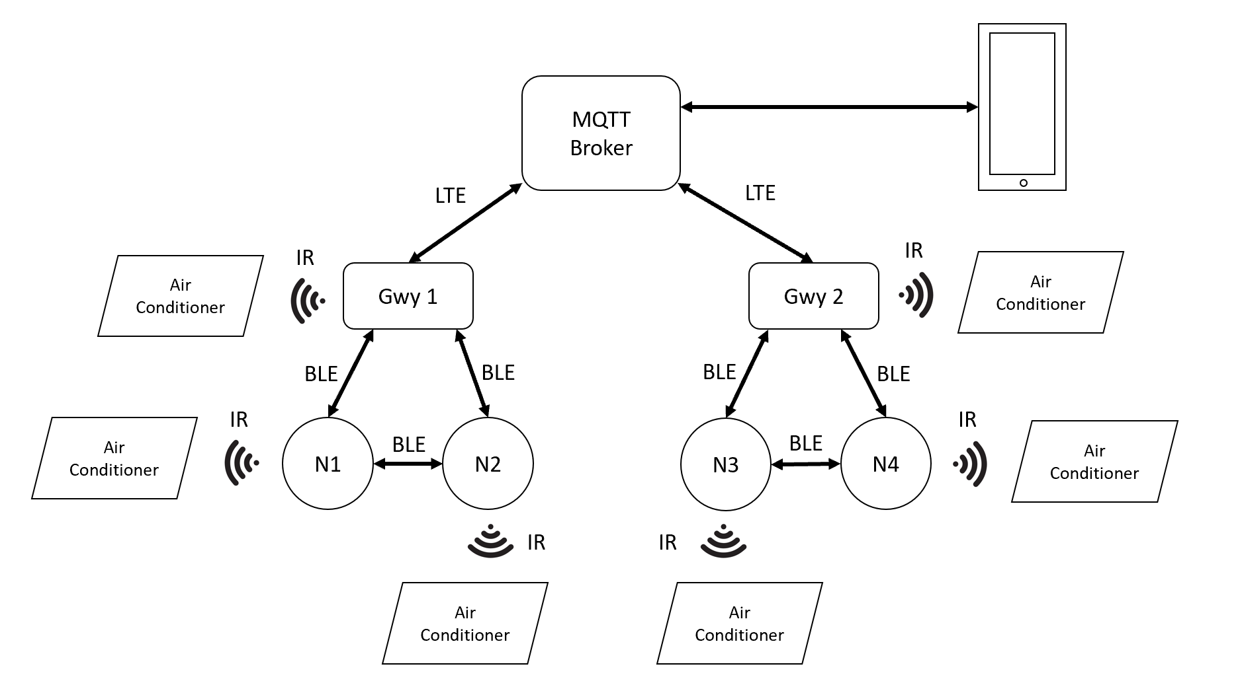
Figure 4.1 Software Architecture Block Diagram

Basics and Terminologies
BLE Mesh based systems involve a few initial steps to be followed to add/remove devices into/from the network. The following section provides information reg. what those steps/processes are.

MQTT Broker
MQTT Broker acts as the backend system which coordinates messages between the different MQTT clients.

Gateway
Gateway is a type of device in the BLE Mesh network which acts as a mediator between the slave devices (Nodes) and the MQTT Broker. Each Gateway is identified with the BLE Mesh network by their unique serial number. In our application, Gateways also take the role as BLE Mesh Provisioner, which means, they can add Nodes into the BLE Mesh network and remove Nodes from the BLE Mesh network Gateways can’t communicate among themselves.

Registration
Registration is the process of adding a Gateway device into the BLE Mesh network.

Unregistration
Unregistration is the process of removing a Gateway device from the BLE Mesh network.

Node
Node is a type of device in the BLE Mesh network which acts as slaves. Typically, Nodes on a BLE Mesh network don’t communicate with the MQTT Broker directly. They will communicate via Gateway to the MQTT Broker. But, since it’s a mesh network, Nodes can communicate to Gateways out of their communication range by the concept of relaying the message through a chain of nodes that will reach the Gateway.

Provisioning
Provisioning is the process of adding a Node device into the BLE Mesh network.

Unprovisioning
Unprovisioning is the process of removing a Node device from the BLE Mesh network.

AC Remote Configuration
This procedure is shared by Node and Gwy. It is necessary to complete this procedure before attempting to operate an air conditioner. A Gwy/Node will identify which AC remote it will function as through this configuration process. See Gateway AC Remote Configuration ACK or Node AC Remote Configuration ACK for further details on this.

Teaching Mode
Teaching mode is a process, in which a sequence of IR signals is sent out from the Physical AC remote, recorded on Gwy/Node and made to be replayed back on-command to control the ACs. For more information regarding Teaching Mode, look at Gateway Teaching Mode Start Packet or Node Teaching Mode Start Packet.

Teaching mode makes it possible for Gwy/Node to be able to only switch ON/OFF or Set Temperature for unsupported AC protocols. For supported AC protocols, the Gwy/Node will be able to control the following parameters displayed in Table 5.1, provided it is supported by the AC in the first place. Look at Table 5.2 for the list of supported AC Brands.

Table 5.1 – AC control parameters for Supported protocol
Sl. No | Parameter
1 | Power
2 | Temperature
3 | FanSpeed
4 | Mode
5 | Swing Horizontal
6 | Swing Vertical
7 | On Timer
8 | Off Timer

List of AC Brands Supported by Gwy/Node
Note: An AC manufacturer may have different AC protocols for different models of their Air conditioners. So, it’s not that the Gwy/Node will be able to contain any model of Air conditioner from the list of brands listed in Table 5.2 below. If an AC remote is unsupported, then the device will emit blinking RED LED indication and also an ACK with AC_REMOTE_UNSUPPORTED error code is sent back.
Table 5.2 – List of Supported AC Brands
Sl. No | AC Brand
1 | Daikin
2 | LG
3 | Voltas
4 | Samsung
5 | Hitachi
6 | Haier
7 | Carrier
8 | Toshiba
9 | Mitsubishi

MQTT Publishing
In MQTT, publishing is the concept of sending data to a specific topic. Topics are like channels in MQTT. There can be any number of topics and all topics are unique. Devices that have subscribed to the topic will receive data from that topic.

MQTT Subscribing
In MQTT, Subscribing is the concept of listening for data from a specific topic.

Gateway LED Indications
Table 6.1 Gateway LED Indication
Sl. No | Pattern | Description
1 | Toggle Red + Green + Blue | Gateway has booted successfully. The LED will stay in this pattern for 3s and then resume normal operation and will be in one of the states below.
2 | Solid Red | Gateway is not connected with MQTT server
3 | Toggling Red + Blue (500ms Red ON, Blue OFF | 500ms Red OFF, Blue ON) | Gateway is not registered
4 | Solid BLUE | Gateway is in AC remote configuration mode
5 | Blinking BLUE | Gateway is in Teaching mode
6 | Solid Green | Gateway is connected to MQTT, Registered and Configured. Meaning, the Gateway is fully operational
7 | Solid Purple | Gateway is sending out an IR command. This is momentary. This will last less than a second.
8 | Blinking RED (200ms ON | 200ms OFF) x3 | Unsupported remote detected during AC Remote Configuration process.

Node LED Indications
Table 7.1 Node LED Indication
Sl. No | Parameter | Description
1 | Toggle Red + Green + Blue | Node has booted successfully. The LED will stay in this pattern for 3s and then resume normal operation and will be in one of the states below.
2 | Toggling Red + Blue (500ms Red ON, Blue OFF | 500ms Red OFF, Blue ON) | Node is not Provisioned
3 | Solid BLUE | Node is in AC remote configuration mode
4 | Blinking BLUE | Node is in Teaching mode
5 | Solid Green | The node is provisioned and configured. Meaning, the node is fully operational
6 | Solid Purple | Gateway is sending out an IR command. This is momentary. This will last less than a second.
7 | Blinking RED (200ms ON | 200ms OFF) x3 | Unsupported remote detected during AC Remote Configuration process.

Gateway Button Press Logics
Table 8.1 Gateway Button Press Logic
Sl. No | Button Press type | Action
1 | Single press | Enables/Disables logging (Only for QMAX Internal use)
2 | Long press for 3s – 8s | Enters/Exits the Gateway into/from teaching mode
3 | Long press for >= 9s | Restarts the Gateway

Node Button Press Logics
Table 9.1 Node Button Press Logics
Sl. No | Parameter | Description
1 | Single press | Enables/Disables logging (Only for QMAX Internal use)
2 | Long press for 3s – 8s | Enters/Exits the Node into/from teaching mode
3 | Long press for >= 9s | Restarts the Node

MQTT Communication Packets
The communication between Gateway and Cloud is based on JSON packets. Communication can take place in both directions i.e., from the gateway to the cloud and vice versa.
Note: If a packet name has “ACK” at its end, then it means, the origin of the packet is from the device’s side. All other packets have origin from the Cloud end.

Table 10.1 MQTT Communication Packets
Packet Name | Packet ID | Packet Description
GATEWAY MQTT PACKETS
Gateway Registration Packet | 0 | Adds a Gwy into BLE Mesh network
Gateway AC Remote Configuration ACK | 1 | Sent back as ACK to cloud. Contains information about Gateway AC remote configuration
Gateway Unregistration Packet | 2 | Removes a Gwy from BLE Mesh network
Gateway AC Control Packet | 3 | Contains AC control settings to control AC using Gwy
Gateway AC Manual control ACK | 4 | Sent back as ACK to cloud. Contains information about manual control of AC using remote
Gateway AC Remote Reconfiguration Packet | 5 | Puts Gwy into AC remote configuration mode
Gateway Heartbeat ACK | 6 | Sent back as ACK to cloud. Contains current AC setting and ambient temperature information
Gateway Heartbeat Publish Configuration Packet | 7 | Tells the Gwy, how frequently it needs to send the Heartbeat ACK to cloud
Gateway Teaching Mode Start Packet | 8 | Puts the Gateway in AC remote teaching mode
Gateway Teaching Mode End ACK | 9 | Sent back as ACK to cloud. Tells if the Gwy has exited Teaching mode or not.
Gateway Debug Info Packet | 10 | To get information like Firmware details, Registration, Configuration statuses from Gwy (Only for QMAX Internal use)
NODE MQTT PACKETS
Node Provisioning Packet | 100 | Adds a Node into BLE Mesh network
Node AC Remote Configuration ACK | 101 | Sent back as ACK to cloud. Contains information about Node AC remote configuration
Node Unprovisioning Packet | 102 | Removes a Node from BLE Mesh network
Node AC control Packet | 103 | Contains AC control settings to control AC using Node
Node AC Manual Control ACK | 104 | Sent back as ACK to cloud. Contains information about manual control of AC using remote
Node AC Remote Reconfiguration Packet | 105 | Puts Node into Configuration mode
Node Heartbeat ACK | 106 | Sent back as ACK to cloud. Contains ambient temperature value measured by the on-board Temperature sensor on Node
Node Heartbeat Publish Configuration Packet | 107 | Tells the Node, how frequently it needs to send the Heartbeat ACK to Gwy
Node Teaching Mode Start Packet | 108 | Puts a Node into AC Remote teaching mode.
Node Teaching Mode End ACK | 109 | Sent back as ACK to cloud. Tells if the Node has exited Teaching mode or not.
Node Debug Info Packet | 110 | To get information like Firmware details, Registration, Configuration statuses from Node (Only for QMAX Internal use)

Error codes
Below table contains all the error codes used across the application.

Table 10.2 Error Codes
Error code | Error code name
-1 | FAILURE
0 | SUCCESS
1 | JSON_PACKET_ID_NOT_FOUND
2 | JSON_PACKET_ID_UNKNOWN
3 | MSG_SEQ_NO_NOT_FOUND
4 | GWY_SER_NO_NOT_FOUND
5 | GWY_SER_NO_INVALID
6 | LOCATION_NOT_FOUND
7 | LOCATION_EXCEEDING_RANGE
8 | NODE_COMM_TIMEOUT
9 | GWY_NOT_REG
10 | GWY_ALREADY_REG
11 | MAC_ID_NOT_FOUND
12 | MAC_ID_CONTAINS_INVALID_CHARS_OR_INVALID_FORMAT
13 | INVALID_MAC_ID_LENGTH
14 | NODE_SER_NO_NOT_FOUND
15 | ELEMENT_ADDR_NOT_FOUND
16 | GWY_NOT_CONFIGURED_WITH_AC_REMOTE
17 | NODE_NOT_CONFIGURED_WITH_AC_REMOTE
18 | POWER_NOT_FOUND
19 | POWER_EXCEEDING_RANGE
20 | MODE_NOT_FOUND
21 | MODE_EXCEEDING_RANGE
22 | FAN_SPEED_NOT_FOUND
23 | FANSPEED_EXCEEDING_RANGE
24 | TEMPERATURE_NOT_FOUND
25 | TEMPERATURE_EXCEEDING_RANGE
26 | SWING_H_NOT_FOUND
27 | SWING_H_EXCEEDING_RANGE
28 | SWING_V_NOT_FOUND
29 | SWING_V_EXCEEDING_RANGE
30 | ONTIMER_NOT_FOUND
31 | ONTIMER_EXCEEDING_RANGE
32 | OFFTIMER_NOT_FOUND
33 | OFFTIMER_EXCEEDING_RANGE
34 | LOCKING_NOT_FOUND
35 | LOCKING_EXCEEDING_RANGE
36 | TEMP_LOCK_UP_LIMIT_NOT_FOUND
37 | TEMP_LOCK_LOW_LIMIT_NOT_FOUND
38 | TEMP_LOCK_UP_LIMIT_EXCEEDS_ABS_TEMP_UP_LIMIT
39 | TEMP_LOCK_LOW_LIMIT_EXCEEDS_ABS_TEMP_LOW_LIMIT
40 | ILLOGICAL_LOCKING_TEMP_LIMIT
41 | PUBLISH_PERIOD_NOT_FOUND
42 | PUBLISH_PERIOD_EXCEEDS_RANGE
43 | MSG_SEQ_NO_EXCEEDING_RANGE
44 | NODE_SER_NO_INVALID
45 | RESET_DEVICE_NOT_FOUND
46 | LOGGING_FLAG_NOT_FOUND
47 | AC_REMOTE_UNSUPPORTED
48 | JSON_PACKET_INVALID
999 | FORBIDDEN_OPERATION
9999 | UNKNOWN ERROR CODE

FAILURE
This error code is generated when the desired operation fails to perform. Although currently not being used in any ACKs.

SUCCESS
This error code is generated when the desired operation is successful.

JSON_PACKET_ID_NOT_FOUND
When an MQTT packet is received by the Gateway without a JsonPacketId parameter in it, the following JSON gets sent as ACK:
{
 | “ErrorCode” | : | 1 | // (Number)
}

JSON_PACKET_ID_UNKNOWN
When an MQTT packet is sent with a JsonPacketId that’s not in the Table 10.1, then the following JSON gets sent as ACK:
{
 | “ErrorCode” | : | 2 | // (Number)
}

MSG_SEQ_NO_NOT_FOUND
This error code is generated when any MQTT packet is received by the Gateway without a MsgSeqNo parameter in it.

GWY_SER_NO_NOT_FOUND
This error code is generated when any MQTT packet is received by the Gateway without a GwySerNo parameter in it.

GWY_SER_NO_INVALID
This error code is generated when any MQTT packet is received by the Gateway with a GwySerNo parameter that is either of invalid format or doesn’t match with the device’s GwySerNo.

LOCATION_NOT_FOUND
This error code is generated when any MQTT packet is received by the Gateway without a Location parameter in it.

LOCATION_EXCEEDING_RANGE
This error code is generated when any MQTT packet is sent with a Location parameter, whose length value exceeds the range mentioned in the packet information.

NODE_COMM_TIMEOUT
This error code is generated when any Node related MQTT packet is sent from Cloud to Gwy and no ACK from the intended Node was received by the Gwy within 10s from when the packet was sent from Gwy to Node.

GWY_NOT_REG
This error code is generated when Gwy receives any of the following packets when it remains unregistered:
- Gateway Unregistration Packet
- Gateway AC Control Packet
- Gateway AC Remote Reconfiguration Packet
- Gateway Heartbeat Publish Configuration Packet
- Gateway Teaching Mode Start Packet
- Node Provisioning Packet
- Node Unprovisioning Packet
- Node AC Control Packet
- Node AC Remote Reconfiguration Packet
- Node Heartbeat Publish Configuration Packet
- Node Teaching Mode Start Packet
- Node Debug Info Packet

GWY_ALREADY_REG
This error code is generated when Gwy receives Gateway Registration Packet when it is already a registered device.

MAC_ID_NOT_FOUND
This error code is generated when any MQTT packet is received by the Gateway without a MacId parameter in it.

MAC_ID_CONTAINS_INVALID_CHARS_OR_INVALID_FORMAT
This error code is generated when any MQTT packet is sent with a MacId that consists of any of the following:
- Contains Invalid characters. Valid Mac Id will contain only [0-9], [a-f], [A-F].
- Contains Invalid Format. Valid Mac Id format in our case is 6 sets of 2-characters separated by a colon between them. Like this: AB:56:7F:88:9E:62

INVALID_MAC_ID_LENGTH
This error code is generated when any MQTT packet is sent with a MacId that’s of Invalid Length. A Valid MacId in our case should be 17 characters in length. (including Colon)

NODE_SER_NO_NOT_FOUND
This error code is generated when any Node Related MQTT packet is received by the Gateway without a NodeSerNo parameter in it.

ELEMENT_ADDR_NOT_FOUND
This error code is generated when any Node Related MQTT packet (Except Node Provisioning Packet) is sent without an ElementAddr parameter in it.

GWY_NOT_CONFIGURED_WITH_AC_REMOTE
This error code is generated when Gwy receives any of the following packets when it remains Unconfigured:
- Gateway AC Control Packet
- Gateway AC Remote Reconfiguration Packet

NODE_NOT_CONFIGURED_WITH_AC_REMOTE
This error code is generated when Gwy receives any of the following packets when the intended Node remains Unconfigured:
- Node AC Control Packet
- Node AC Remote Reconfiguration Packet

POWER_NOT_FOUND
This error code is generated when a Gateway AC Control Packet or Node AC control packet is received by the Gateway without a Power parameter in it.

POWER_EXCEEDING_RANGE
This error code is generated when a Gateway AC Control Packet or Node AC control packet is received by the Gateway with a Power parameter, whose value is neither 1 nor 0.

MODE_NOT_FOUND
This error code is generated when a Gateway AC Control Packet or Node AC control packet is received by the Gateway without a Mode parameter in it.

MODE_EXCEEDING_RANGE
This error code is generated when a Gateway AC Control Packet or Node AC control packet is received by the Gateway with a Mode parameter, whose value is neither of the following:
- Cool
- Hot
- Dry
- Auto
- Fan
Please make note, the above is CASE SENSITIVE.

FAN_SPEED_NOT_FOUND
This error code is generated when a Gateway AC Control Packet or Node AC control packet is received by the Gateway without a FanSpeed parameter in it

FANSPEED_EXCEEDING_RANGE
This error code is generated when a Gateway AC Control Packet or Node AC control packet is received by the Gateway with a FanSpeed parameter, whose value is not between 0 – 5.

TEMPERATURE_NOT_FOUND
This error code is generated when a Gateway AC Control Packet or Node AC control packet is received by the Gateway without a Temperature parameter in it.

TEMPERATURE_EXCEEDING_RANGE
This error code is generated when a Gateway AC Control Packet or Node AC control packet is received by the Gateway with a Temperature parameter, whose value is not between 18 – 32.

SWING_H_NOT_FOUND
This error code is generated when a Gateway AC Control Packet or Node AC control packet is received by the Gateway without a SwingH parameter in it.

SWING_H_EXCEEDING_RANGE
This error code is generated when a Gateway AC Control Packet or Node AC control packet is received by the Gateway with a SwingH parameter, whose value is neither 1 nor 0.

SWING_V_NOT_FOUND
This error code is generated when a Gateway AC Control Packet or Node AC control packet is received by the Gateway without a SwingV parameter in it.

SWING_V_EXCEEDING_RANGE
This error code is generated when a Gateway AC Control Packet or Node AC control packet is received by the Gateway with a SwingV parameter, whose value is neither 1 nor 0.

ONTIMER_NOT_FOUND
This error code is generated when a Gateway AC Control Packet or Node AC control packet is received by the Gateway without an OnTimer parameter in it.

ONTIMER_EXCEEDING_RANGE
This error code is generated when a Gateway AC Control Packet or Node AC control packet is received by the Gateway with an OnTimer, whose value is not between 0 – 12.

OFFTIMER_NOT_FOUND
This error code is generated when a Gateway AC Control Packet or Node AC control packet is received by the Gateway without an OffTimer parameter in it.

OFFTIMER_EXCEEDING_RANGE
This error code is generated when a Gateway AC Control Packet or Node AC control packet is received by the Gateway with an OffTimer parameter, whose value is not between 0 – 12.

LOCKING_NOT_FOUND
This error code is generated when a Gateway AC Control Packet or Node AC control packet is received by the Gateway without a Locking parameter in it.

LOCKING_EXCEEDING_RANGE
This error code is generated when a Gateway AC Control Packet or Node AC control packet is received by the Gateway with a Locking parameter, whose value is neither 1 nor 0.

TEMP_LOCK_UP_LIMIT_NOT_FOUND
This error code is generated when a Gateway AC Control Packet or Node AC control packet is received by the Gateway without a TempLockUpLimit parameter in it.

TEMP_LOCK_LOW_LIMIT_NOT_FOUND
This error code is generated when a Gateway AC Control Packet or Node AC control packet is received by the Gateway without a TempLockLowLimit parameter in it.

TEMP_LOCK_UP_LIMIT_EXCEEDS_ABS_TEMP_UP_LIMIT
This error code is generated when a Gateway AC Control Packet or Node AC control packet is received by the Gateway with a TempLockUpLimit parameter, whose value is greater than 32.

TEMP_LOCK_LOW_LIMIT_EXCEEDS_ABS_TEMP_LOW_LIMIT
This error code is generated when a Gateway AC Control Packet or Node AC control packet is received by the Gateway with a TempLockLowLimit parameter, whose value is less than 18.

ILLOGICAL_LOCKING_TEMP_LIMIT
This error code is generated when a Gateway AC Control Packet or Node AC control packet is received by the Gateway with a TempLockLowLimit parameter, whose value is higher than TempLockUpLimit parameter’s value.

PUBLISH_PERIOD_NOT_FOUND
This error code is generated when a Gateway Heartbeat Publish Configuration Packet or Node Heartbeat Publish Configuration packet is received by the Gateway without a PublishPeriodSec parameter in it.

PUBLISH_PERIOD_EXCEEDS_RANGE
This error code is generated when a Gateway Heartbeat Publish Configuration Packet or Node Heartbeat Publish Configuration packet is received by the Gateway with a PublishPeriodSec parameter, whose value is not between 10 – 255.

MSG_SEQ_NO_EXCEEDING_RANGE
This error code is generated when any MQTT packet is received by the Gateway with a MsgSeqNo parameter, whose value is not between 0 – 65535.

NODE_SER_NO_INVALID
This error code is generated when any MQTT packet is received by the Gateway with a NodeSerNo parameter that is either of invalid format or doesn’t match with the intended Node’s NodeSerNo. Due to technical difficulties, this will not be applicable for Node Provisioning packet

RESET_DEVICE_NOT_FOUND
This error code is generated when Gwy Debug Info or Node Debug Info packet is received by the Gwy without ResetDevice parameter in it.

LOGGING_FLAG_NOT_FOUND
This error code is generated when Gwy Debug Info or Node Debug Info packet is received by the Gwy without Logging parameter in it.

FORBIDDEN_OPERATION
Reserved for future use.

UNKNOWN ERROR CODE
Reserved for future use

AC_REMOTE_UNSUPPORTED
This error code is generated when an unsupported AC remote is used for AC Remote configuration process.

JSON_PACKET_INVALID
This error code is generated when any incorrectly formatted JSON message is received from the cloud. If the format is incorrect, it’s not possible to parse that JSON message any further.

Common JSON parameters
The following parameters are used across most of the MQTT communication packets. Below table provides information about these parameters and the purpose behind them.

Table 10.3 Common JSON Parameter description
Sl. No | Parameter | Description
1 | JsonPacketId | This is used for identification on both cloud side and Gwy side to know which packet is being received
2 | MsgSeqNo | The message sequence number is used to identify which ACK corresponds to which command.
3 | GwySerNo | Serial Number to identify a particular Gwy.
4 | Error Code | Included on all ACK packets. Let’s the cloud know if the operation has succeeded or needs attention.
5 | Location | This is used to identify the physical location of where the device was installed. User sets this information upon Registration / Provision process.
6 | NodeSerNo | Serial Number to identify a particular Node.
7 | ElementAddr | A Number used for communication to Node inside the BLE network.

Gateway Registration Packet
Description: This packet is used to add a Gwy device into the BLE Mesh network.
LED Indication: When in Unregistered state, Gateway blinks RED + BLUE.

Gateway Registration JSON (Cloud to Gateway):
{ |  |  |  |  | Range
 | “JsonPacketId” | : | 0 | // (Number)
 | “MsgSeqNo” | : | 12 | // (Number) | [0 - 65535]
 | “GwySerNo” | : | “GWY00001” | // (String) | [00001 - 99999]
 | “Location” | : | “1st Floor” | // (String) | [30 chars long]
}

Process flow diagram:

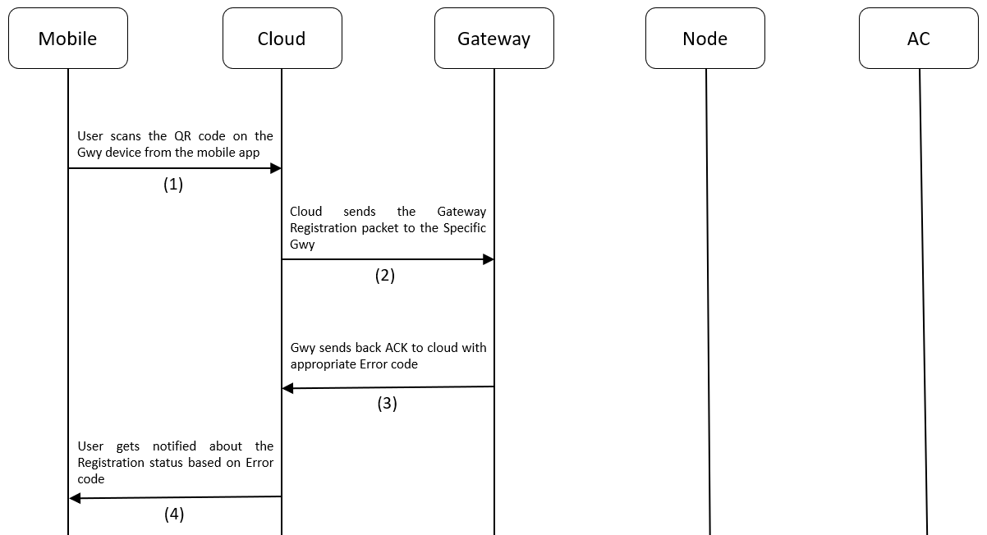

Figure 10.1 Gateway Registration process flow

Gateway Registration ACK
Description: This ACK is used by cloud to know whether the Gwy registration was successful or not. Gateway sends back this packet after receiving Gateway Registration packet.

Gateway Registration ACK JSON (Gateway to Cloud):
{ |  |  |  |  | Range
 | “JsonPacketId” | : | 0 | // (Number)
 | “JsonAckName” | : | “Gwy Registration Ack” | // (String)
 | “MsgSeqNo” | : | 12 | // (Number) | [0 - 65535]
 | “GwySerNo” | : | “GWY00001” | // (String) | [00001 - 99999]
 | “Location” | : | “1st Floor” | // (String) | [30 chars long]
 | “ErrorCode” | : | 0 | // (Number)
}

Link To Error Code Reference: Error Codes

Process flow diagram:



Figure 10.2 Gateway Registration process flow

Gateway AC Remote Configuration ACK
Description: This is an ACK sent by Gwy to Cloud when the Gwy is successfully configured with an AC remote. When Gwy is in AC Remote Configuration mode (Slow Blinking BLUE light), and AC remote is pressed in-front of the IR receiver in the Gwy, it will get configured to act as that AC remote from there on and send this ACK to the cloud.

LED Indication: If not configured, Gateway will glow Solid BLUE LED, meaning the Gateway is in AC Remote configuration mode.

Gateway AC Remote Configuration ACK JSON (Gateway to Cloud):
{ |  |  |  |  | Range
 | “JsonPacketId” | : | 1 | // (Number)
 | “JsonAckName” | : | “Gwy AC Remote Configuration Ack” | // (String)
 | “GwySerNo” | : | “GWY00001” | // (String) | [00001 - 99999]
 | “ErrorCode” | : | 0 | // (Number)
}

Link To Error Code Reference: Error Codes

Process flow:

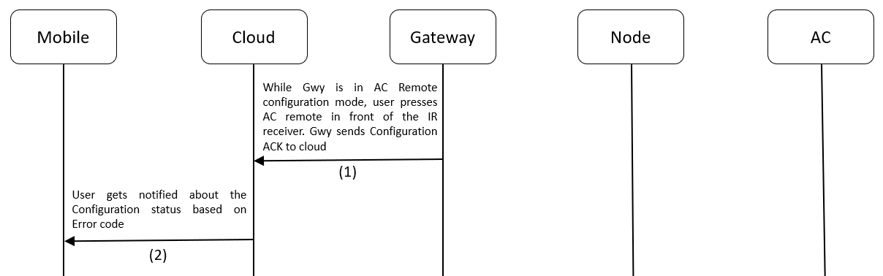

Figure 10.3 Gateway Configuration process flow

Gateway Unregistration Packet
Description: This packet is used to remove a Gwy device from the BLE Mesh network.
Note: When a Gateway is Unregistered, it will reset itself to factory settings. But it will still retain its current mesh network information.

Gateway Unregistration JSON (Cloud to Gateway):
{ |  |  |  |  | Range
 | “JsonPacketId” | : | 2 | // (Number)
 | “MsgSeqNo” | : | 12 | // (Number) | [0 - 65535]
 | “GwySerNo” | : | “GWY00001” | // (String) | [00001 - 99999]
 | “Location” | : | “1st Floor” | // (String) | [30 chars long]
}

Process flow:

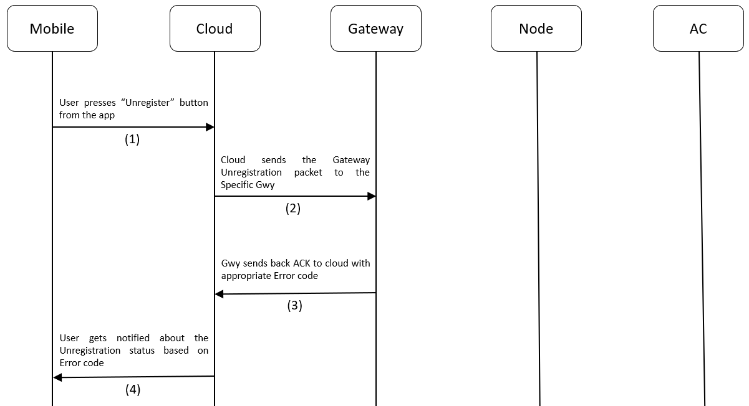

Figure 10.4 Gateway Unregistration Process flow

Gateway Unregistration ACK
Description: This ACK is used by cloud to know whether the Gwy Unregistration was successful or not. This packet will be sent by Gateway after receiving Gateway Unregistration packet.

Gateway Unregisration ACK JSON (Gateway to Cloud):
{
 | “JsonPacketId” | : | 2 | // (Number)
 | “JsonAckName” | : | “Gwy Unregistration Ack” | // String)
 | “MsgSeqNo” | : | 12 | // (Number)
 | “GwySerNo” | : | “GWY00001” | // (String)
 | “Location” | : | “1st Floor” | // (String)
 | “ErrorCode” | : | 0 | // (Number)
}

Link To Error Code Reference: Error Codes

Process flow:



Figure 10.5 Gateway Unregistration Process Flow

Gateway AC Control Packet
Description: This packet is used to control an AC using the Gwy. The below table describes the AC control parameters that go with the Gateway AC Control Packet.

Table 10.4 AC Control Parameters
Sl. No | Parameter | Description
1 | Power | 1 = ON, 0 = OFF
2 | Mode | The following modes are supported: [Cool, Dry, Hot, Fan, auto].
3 | FanSpeed | [1 - 5] levels
3 | Temperature | Sets the AC temperature. Must be between 18 and 32.
4 | SwingH | 1 = ON, 0 = OFF
5 | SwingV | 1 = ON, 0 = OFF
6 | OnTimer | Sets the number of hours past midnight after which AC needs to be turned on automatically. [0 – 12]
7 | OffTimer | Sets the number of hours past midnight after which AC needs to be turned off automatically [0 – 12]
8 | Locking | 1 = ON, 0 = OFF. When ON, if AC was controlled manually, then Gateway Manual AC Control ACK will be sent to Cloud. Also, when ON, the AC will be maintained between the TempLockUpLimit and TempLockLowLimit. If by manual control, AC temp was set exceeding the above limits, then Gwy will emit IR Signal to control the AC and bring it back to whatever setting was set by Gwy lastly.
9 | TempLockUpLimit | Specifies upper temperature locking limit. This parameter will have no effect application wise, when Locking is not enabled. Must have values within the absolute Temperature limits: 18 - 32.
10 | TempLockLowLimit | Specifies Lower temperature locking limit. When Locking is not enabled, this parameter will have no effect application wise. Must have values within the absolute Temperature limits: 18 - 32.

Note: Gateway Manual AC control ACK is applicable only when devices have not undergone the Teaching Mode Process. For Devices, using the Teaching Mode to control ACs, Gateway Manual AC control ACK will be sent with all the AC parameter values set to 0. Example ACK for both the cases is provided in the Gateway Manual AC control ACK section.

Gateway AC Control JSON packet (Cloud to Gateway):
{ |  |  |  |  | Range
 | “JsonPacketId” | : | 3 | // (Number)
 | “MsgSeqNo” | : | 12 | // (Number) | [0 - 65535]
 | “GwySerNo” | : | “GWY00001” | // (String) | [00001 - 99999]
 | “Power” | : | 1 | // (Number) | [0 = OFF, 1 = ON]
 | “Mode” | : | “Cool” | // (String) | [“Cool“, “Dry“, “Auto“, “Fan“, “Hot“]
 | “FanSpeed” | : | 1 | // (Number) | [1 - 5]
 | “Temperature” | : | 25 | // (Number) | [18 - 32]
 | “SwingH” | : | 1 | // (Number) | [0 = OFF, 1 = ON]
 | “SwingV” | : | 1 | // (Number) | [0 = OFF, 1 = ON]
 | “OnTimer” | : | 0 | // (Number) | [0 - 12]
 | “OffTimer” | : | 0 | // (Number) | [0 - 12]
 | “Locking” | : | 1 | // (Number) | [0 = OFF, 1 = ON]
 | “TempLockUpLimit” | : | 26 | // (Number) | [18 - 32]
 | “TempLockLowLimit” | : | 20 | // (Number) | [18 - 32]
}

Process flow:

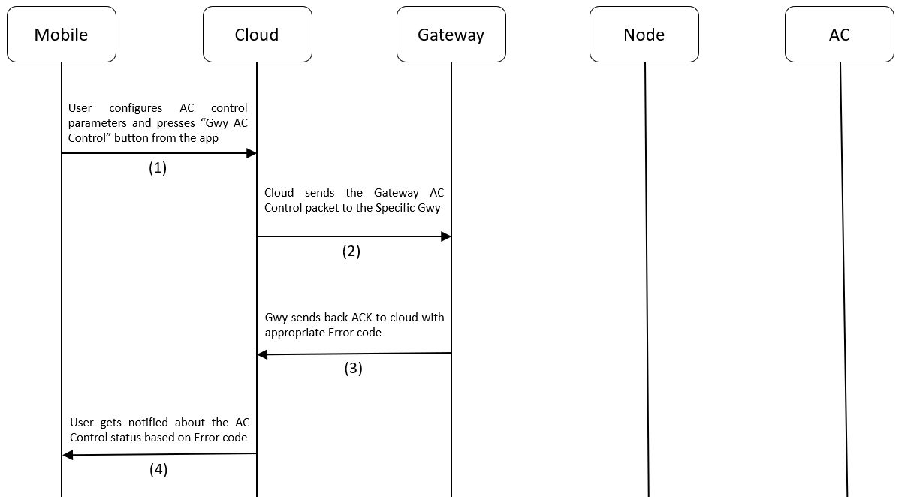

Figure 10.6 Gateway AC Control Process flow

Gateway AC Control ACK
Description: This ACK is used by cloud to know whether the Gwy AC Control was successful or not.

Gateway AC Control ACK JSON (Gateway to Cloud):
{
 | “JsonPacketId” | : | 3 | // (Number)
 | “JsonAckName” | : | “Gwy AC Control Ack” | // (String)
 | “MsgSeqNo” | : | 12 | // (Number)
 | “GwySerNo” | : | “GWY00001” | // (String)
 | “Power” | : | 1 | // (Number)
 | “Mode” | : | “Cool” | // (String)
 | “FanSpeed” | : | 1 | // (Number)
 | “Temperature” | : | 25 | // (Number)
 | “SwingH” | : | 1 | // (Number)
 | “SwingV” | : | 1 | // (Number)
 | “OnTimer” | : | 0 | // (Number)
 | “OffTimer” | : | 0 | // (Number)
 | “Locking” | : | 1 | // (Number)
 | “TempLockUpLimit” | : | 26 | // (Number)
 | “TempLockLowLimit” | : | 20 | // (Number)
 | “ErrorCode” | : | 0 | // (Number)
}

Link To Error Code Reference: Error Codes

Process flow:



Figure 10.7 Gateway AC Control Process flow

Gateway AC Manual control ACK
Description: If Locking was enabled, this ACK is used by cloud to know whether the AC was controlled manually using the AC remote. If someone controls the AC manually using the remote, then the IR receiver on-board will capture this IR signal and decode it. If it’s a signal from the same remote with which the Gateway was configured during the AC Remote configuration process, then it will store the manual control information for sending it to the cloud. Also, it performs logical operation based on the temperature that was set using the remote. If it exceeds the Locking temperature limits set from the AC Control packet, then it will bring the AC’s temperature back to permissible limits.
Note: The Gateway Manual Control ACK will work only for Devices that are not using Teaching Mode to control AC.

Gateway AC Manual Control ACK JSON (Gateway to Cloud) (Non-Teaching Mode case):
{
 | “JsonPacketId” | : | 4 | // (Number)
 | “JsonAckName” | : | “Gwy AC Manual Control ACK” | // (String)
 | “GwySerNo” | : | “GWY00001” | // (String)
 | “Power” | : | 1 | // (Number)
 | “Mode” | : | “Cool” | // (String)
 | “FanSpeed” | : | 1 | // (Number)
 | “Temperature” | : | 25 | // (Number)
}

Gateway AC Manual Control ACK JSON (Gateway to Cloud) (Teaching Mode case):
{
 | “JsonPacketId” | : | 4 | // (Number)
 | “JsonAckName” | : | “Gwy AC Manual Control ACK” | // (String)
 | “GwySerNo” | : | “GWY00001” | // (String)
 | “Power” | : | 0 | // (Number)
 | “Mode” | : | “” | // (String)
 | “FanSpeed” | : | 0 | // (Number)
 | “Temperature” | : | 0 | // (Number)
}
Process flow:
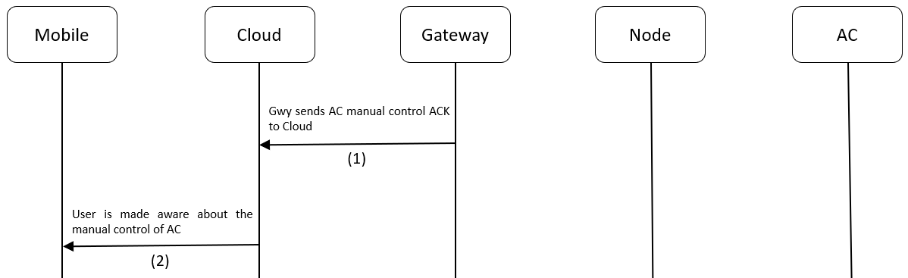

Figure 10.8 Gateway AC manual control Process flow

Gateway AC Remote Reconfiguration Packet
Description: This packet is used to put the Gwy in AC remote configuration mode.

Gateway AC Remote Reconfiguration JSON (Cloud to Gateway):
{ |  |  |  |  | Range
 | “JsonPacketId” | : | 5 | // (Number)
 | “MsgSeqNo” | : | 12 | // (Number) | [0 - 65535]
 | “GwySerNo” | : | “GWY00001” | // (String) | [00001 - 99999]
}

Process flow:

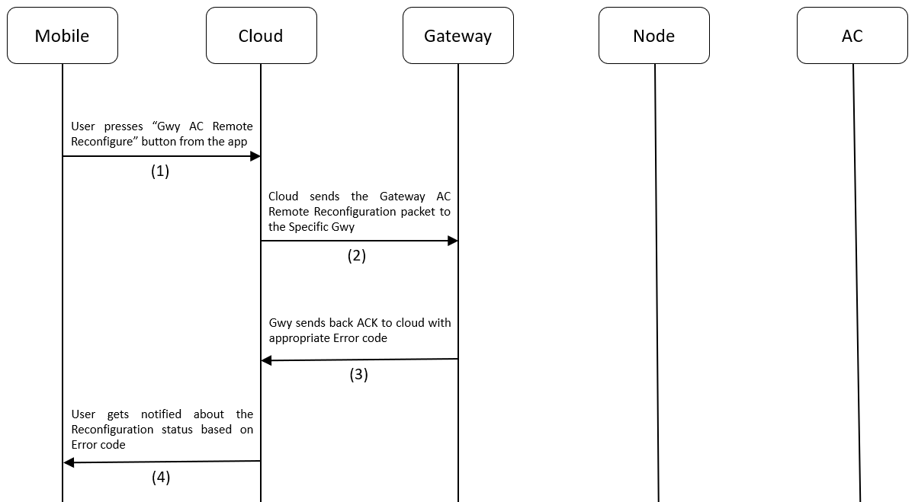

Figure 10.9 Gateway AC Remote Reconfiguration Process Flow

Gateway AC Remote Reconfiguration ACK
Description: This ACK is used by cloud to know if the Gwy has entered AC Remote reconfiguration mode after receiving the Gateway AC Remote Reconfiguration packet.

Led Indication: Gwy will glow solid BLUE to indicate it has entered Gwy AC Remote configuration mode.

Gateway AC Remote Reconfiguration ACK JSON (Gateway to Cloud):

{
 | “JsonPacketId” | : | 5 | // (Number)
 | “JsonAckName” | : | “Gwy AC Remote Reconfiguration Ack” | // (String)
 | “MsgSeqNo” | : | 12 | // (Number)
 | “GwySerNo” | : | “GWY00001” | // (String)
 | “ErrorCode” | : | 0 | // (Number)
}

Link To Error Code Reference: Error Codes

Process flow:



Figure 10.10 Gateway AC Remote Reconfiguration Process flow

Gateway Heartbeat ACK
Description: This ACK is used by cloud to know the Ambient temperature of the environment in which the Gwy is operating as well as the current AC control settings. This ACK is sent periodically to the cloud. This frequency can be configured in the Gateway Heartbeat Publish Configuration Packet.

Gateway Heartbeat ACK JSON (Gateway to Cloud):
{
 | “JsonPacketId” | : | 6 | // (Number)
 | “JsonAckName” | : | “Gwy Heartbeat ACK” | // (String)
 | “GwySerNo” | : | “GWY00001” | // (String)
 | “Power” | : | 1 | // (Number)
 | “Mode” | : | “Cool” | // (String)
 | “FanSpeed” | : | 3 | // (Number)
 | “Temperature” | : | 25 | // (Number)
 | “AmbientTemperature” | : | 25 | // (Number) (Measured from sensor)
 | “SwingH” | : | 1 | // (Number)
 | “SwingV” | : | 0 | // (Number)
 | “OnTimer” | : | 5 | // (Number)
 | “OffTimer” | : | 12 | // (Number)
 | “Locking” | : | 0 | // (Number)
 | “TempLockUpLimit” | : | 27 | // (Number)
 | “TempLockLowLimit” | : | 20 | // (Number)
}

Process flow:

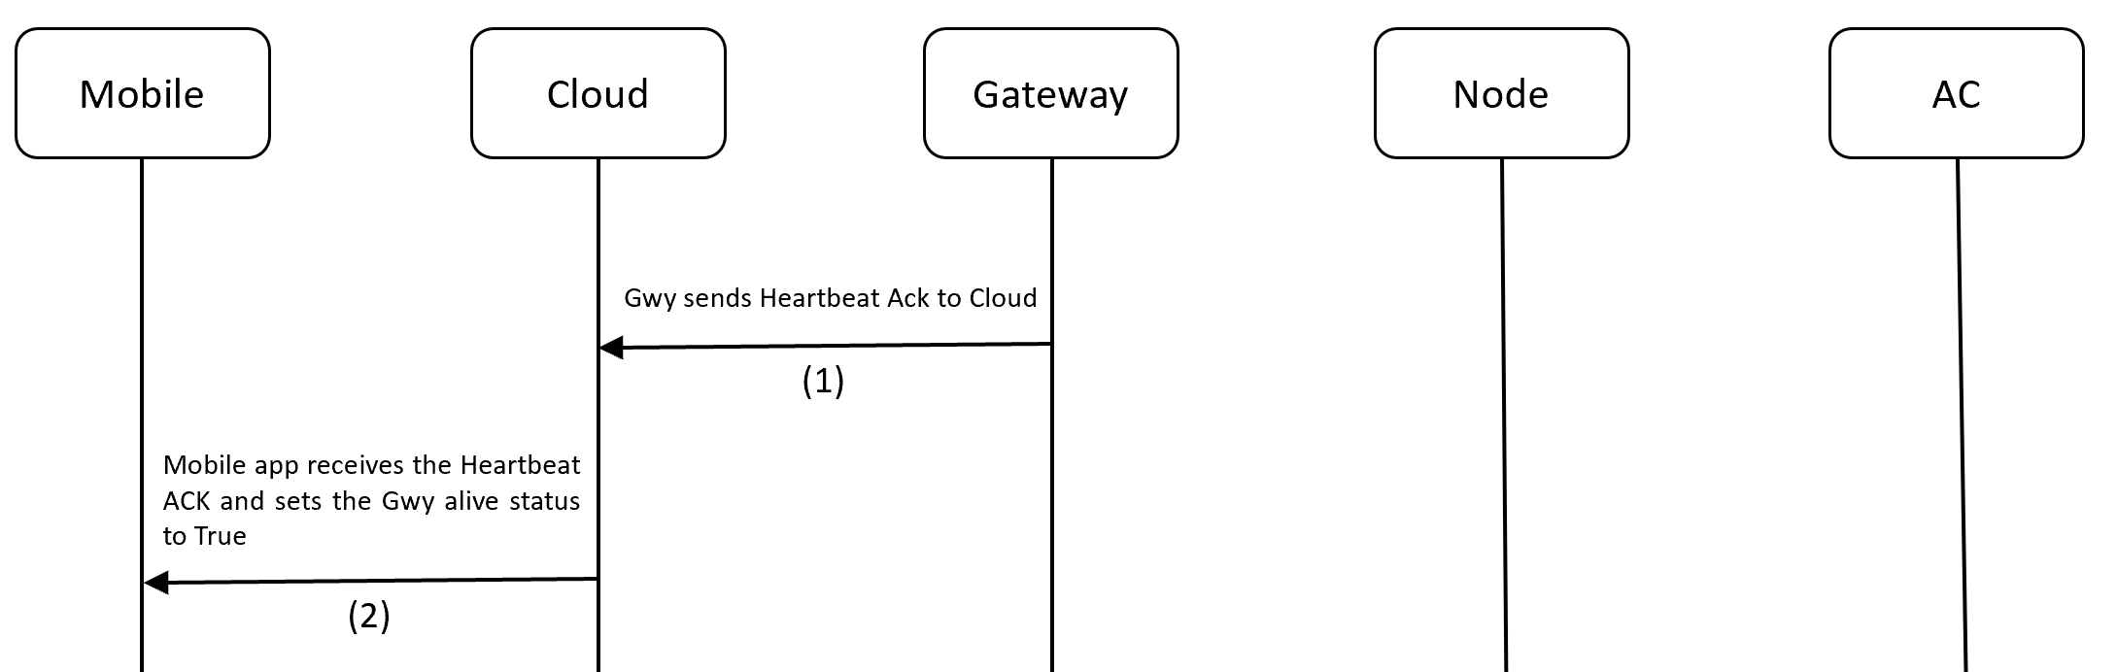

Figure 10.11 Gateway Heartbeat ACK Process flow

Gateway Heartbeat Publish Configuration Packet
Description: This packet is used to tell the Gwy, how frequently it needs to send the Heartbeat ACK to cloud. The frequency is configurable in seconds. The default Value is 10s.

Gateway Heartbeat Publish Configuration JSON (Cloud to Gateway):
{ |  |  |  |  | Range
 | “JsonPacketId” | : | 7 | // (Number)
 | “MsgSeqNo” | : | 12 | // (Number) | [0 – 65535]
 | “GwySerNo” | : | “GWY00001” | // (String) | [00000 - 99999]
 | “PublishPeriodSec” | : | 20 | // (Number) (in Sec) | [300 - 65535]
}

Process flow:

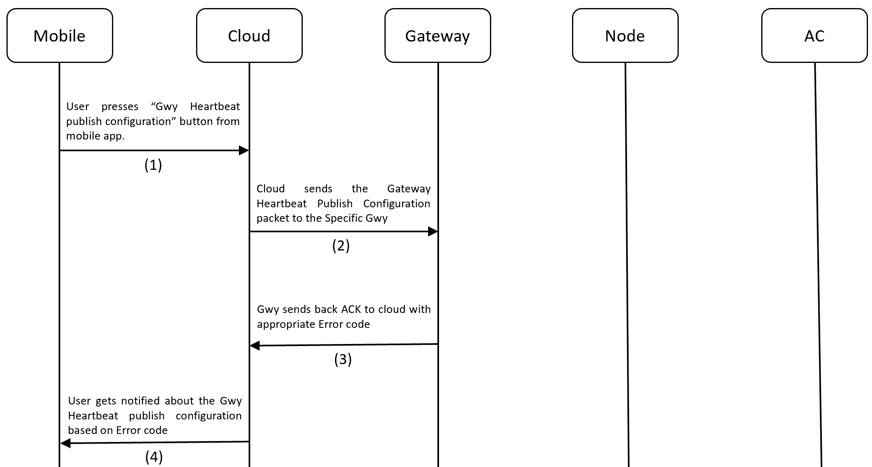

Figure 10.12 Gateway Heartbeat Publish Configuration Process flow

Gateway Heartbeat Publish Configuration ACK
Description: This ACK is used by cloud to know whether the Gateway Heartbeat Publish configuration operation was successful or not.

Gateway Heartbeat Publish Configuration ACK JSON (Gateway to Cloud):
{
 | “JsonPacketId” | : | 7 | // (Number)
 | “JsonAckName” | : | “Gwy Heartbeat Publish Configuration ACK” | // (String)
 | “MsgSeqNo” | : | 12 | // (Number)
 | “GwySerNo” | : | “GWY00001” | // (String)
 | “PublishPeriodSec” | : | 20 | // (Number) (in Sec)
 | “ErrorCode” | : | 0 | // (Number)
}

Link To Error Code Reference: Error Codes

Process flow:



Figure 10.13 Gateway Heartbeat Publish Configuration ACK Process flow

Gateway Teaching Mode Start Packet
Description: This packet is used to make a Gateway enter Teaching mode.

Led Indication: Gwy will glow Blinking BLUE to indicate it has entered Teaching mode.

Gateway Teaching Mode Start JSON (Cloud to Gateway):

{ |  |  |  |  | Range
 | “JsonPacketId” | : | 8 | // (Number)
 | “MsgSeqNo” | : | 12 | // (Number) | [0 – 65535]
 | “GwySerNo” | : | “GWY00001” | // (String) | [00001 - 99999]
}

Process flow:

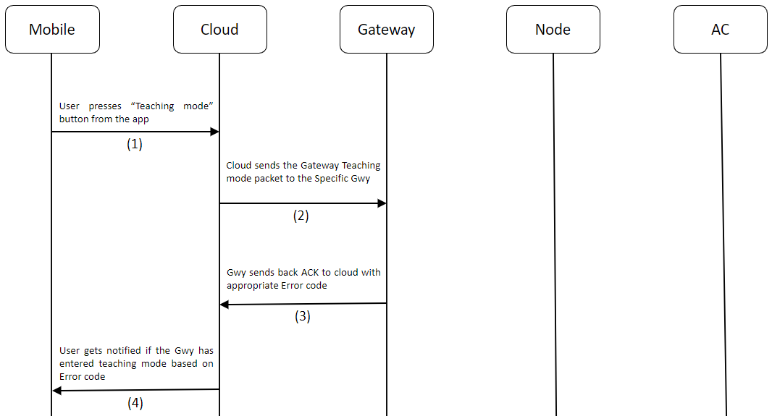

Figure 10.14 Gateway Teaching Mode Start Flow

Steps to Perform Teaching Mode:
- Make sure Gateway is registered / Make sure Node is provisioned.
- IMPORTANT NOTE (before making the device enter Teaching mode): Take the AC remote and bring down the temperature to 19 and power ON the AC. So that, when you press the power button again, it should send the POWER OFF signal. This is very important in-order to successfully register the commands to EEPROM on-board and complete the teaching process. The sequence of IR signals for teaching mode is as follows:
  - POWER OFF | TEMP 19
  - POWER ON | TEMP 19
  - POWER ON | TEMP 20
  - POWER ON | TEMP 21
  - POWER ON | TEMP 22
  - POWER ON | TEMP 23
  - POWER ON | TEMP 24
  - POWER ON | TEMP 25
  - POWER ON | TEMP 26
  - POWER ON | TEMP 27
  - POWER ON | TEMP 28
- Long press the button for 3s – 8s or use the Gateway Teaching Mode Start Packet to put the device into Teaching Mode. The LED will start Fast Blinking BLUE (once every 200ms) to indicate it has entered teaching mode.
- Press the POWER ON button on the AC remote with remote pointing towards to IR receiver on-board for successful reception and prevent false recording.
- The device will read the IR signal from the remote and store it in flash. While this process is happening, the light will turn off momentarily to indicate that no other buttons on AC remote must be pressed to let the process go on without disturbance. Also, make sure you are doing this process in an IR disturbance free environment. Most smartphones these days use IR emitters, so it's one thing that I experienced during my development.
- Once the LED starts blinking BLUE again, it's time to record the next IR signal. The next signal is POWER ON | TEMP 19.
- Similarly, go one-by-one all the way up to POWER ON | TEMP 28. If everything was done right, then, when the last IR signal was sent, the LED will change to SOLID GREEN to indicate successful completion of the Teaching Mode process
Steps to Exit Teaching Mode:

- When already in Teaching Mode, if the button is long pressed for 3s-8s, device will exit teaching mode.

Gateway Teaching Mode Start ACK
Description: This ACK is used by the cloud to know if the Gwy has successfully entered the teaching mode or not after receiving Gateway Teaching Mode Start Packet.

Led Indication: Gwy will glow Blinking BLUE to indicate it has entered Teaching Mode.

Gateway Teaching Mode Start ACK JSON (Gateway to Cloud):

{
 | “JsonPacketId” | : | 8 | // (Number)
 | “JsonAckName” | : | “Gwy Teaching Mode Start ACK” | // (String)
 | “MsgSeqNo” | : | 12 | // (Number)
 | “GwySerNo” | : | “GWY00001” | // (String)
 | “ErrorCode” | : | 0 | // (Number)
}

Link To Error Code Reference: Error Codes

Process flow:



Figure 10.15 Gateway Teaching Mode Start ACK Flow

Gateway Teaching Mode End ACK
Description: This ACK is used by the cloud to know if the Gwy has exited Teaching mode.

Led Indication: On completion of Teaching mode, the Gwy will glow Solid GREEN.

Gateway Teaching Mode End ACK JSON (Gateway to Cloud):

{
 | “JsonPacketId” | : | 9 | // (Number)
 | “JsonAckName” | : | “Gwy Teaching Mode End ACK” | // (String)
 | “GwySerNo” | : | “GWY00001” | // (String)
}

Process flow:

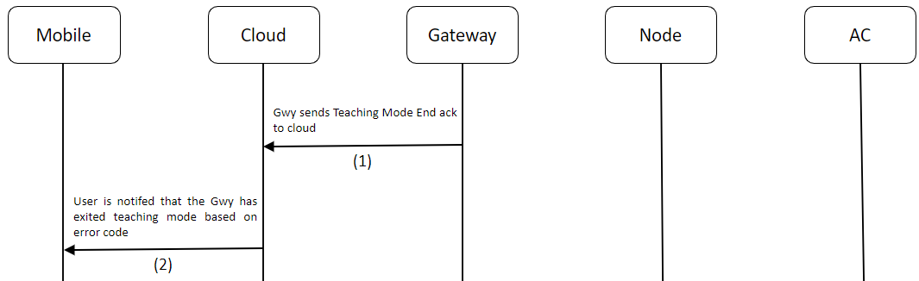

Figure 10.16 Gateway Teaching Mode End ACK Flow

Gateway Debug Info Packet (Only for QMAX Internal use)
Description: This packet is sent to retrieve information from a Gwy device regarding the firmware version it’s currently running, Registration-Configuration statuses, Queue Count, etc., This packet also contains a parameter called logging, which can be used to enable/disable logging during runtime. Logging can also be enabled/disable by Single pressing the button on the device.

Gateway Debug Info Packet JSON (Cloud to Gateway):

{ |  |  |  |  | Range
 | “JsonPacketId” | : | 10 | // (Number)
 | “MsgSeqNo” | : | 12 | // (Number) | [0 – 65535]
 | “GwySerNo” | : | “GWY00001” | // (String) | [00001 - 99999]
 | “Logging” | : | 1 | // (Number) | [0 = OFF, 1 = ON]
 | “ResetDevice” | : | 1 | // (Number) | [0 = False, 1 = True]
}

Process flow:

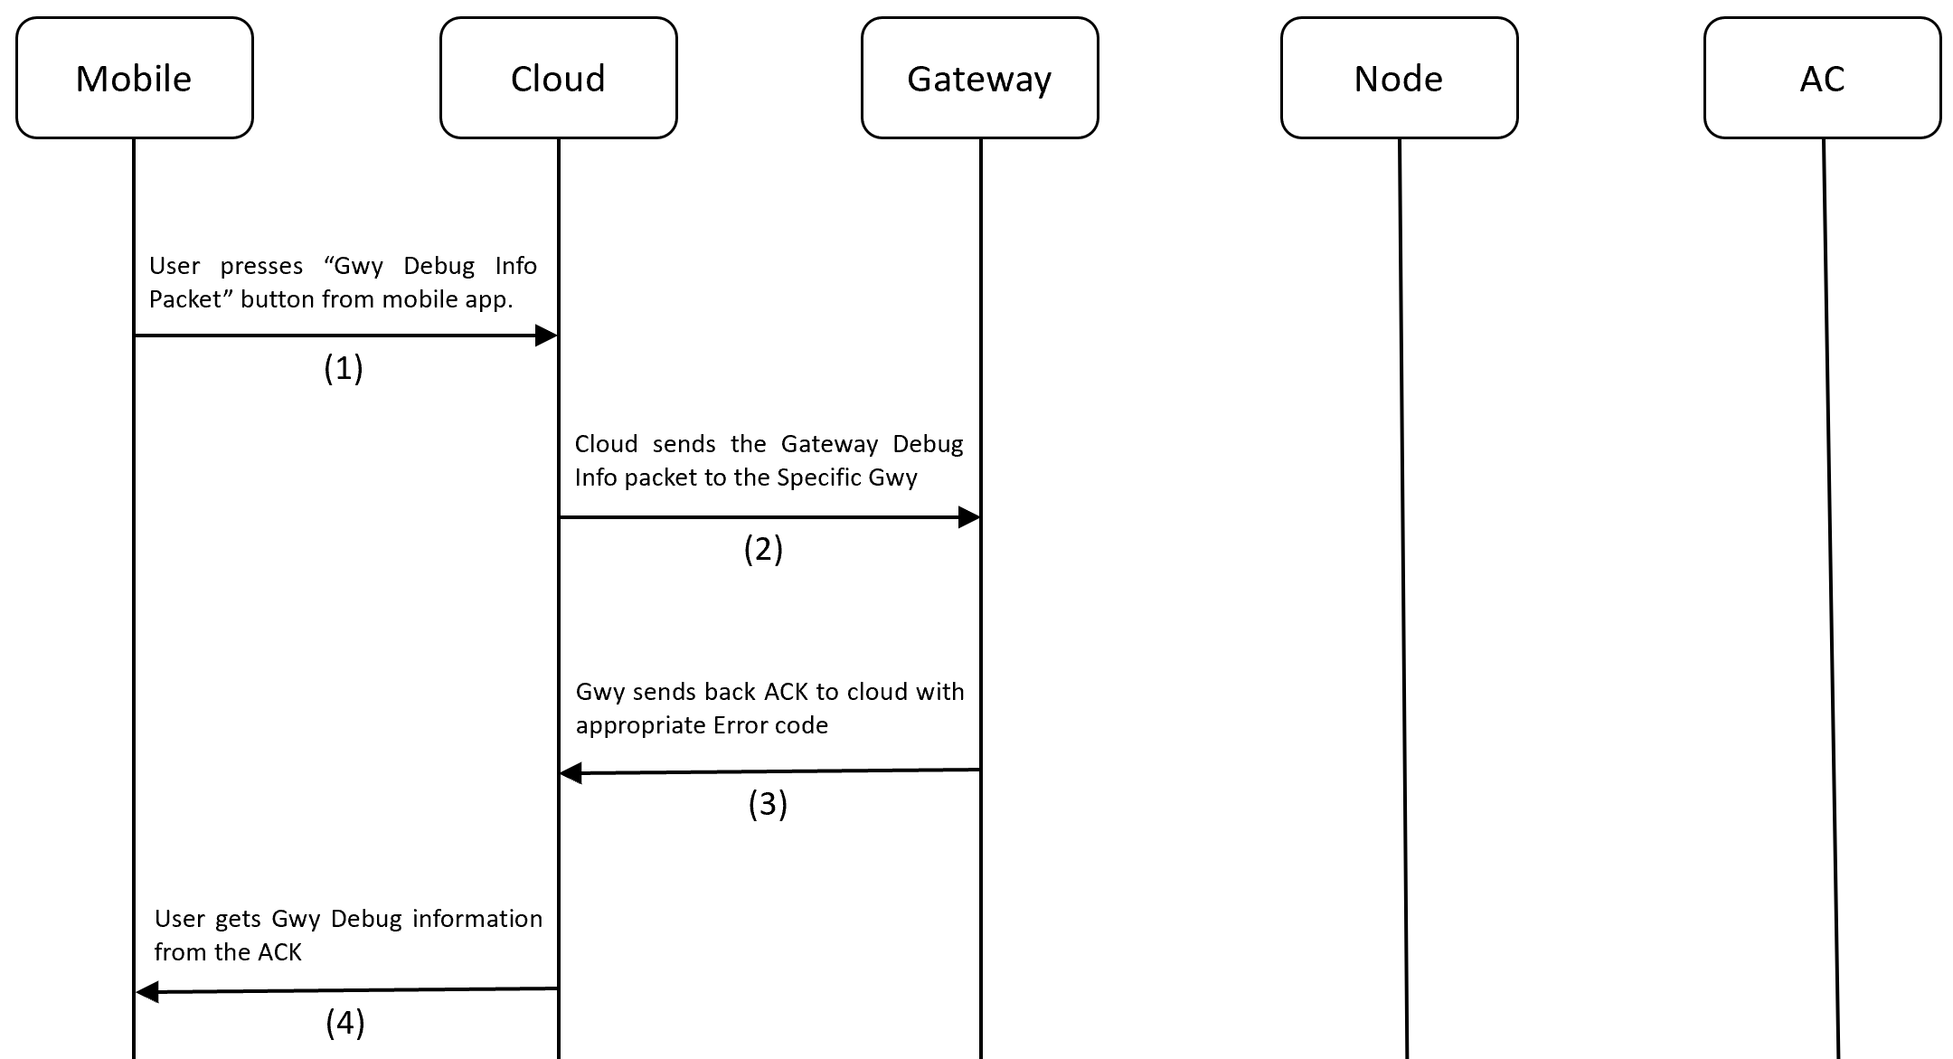

Figure 10.17 Gateway Debug Info Process Flow

Gateway Debug Info ACK (Only for QMAX Internal use)
Description: This ACK is used by Cloud to utilize Debugging information from a Gwy.

Gateway Debug Info Packet ACK JSON (Gateway to Cloud):
{
 | “JsonPacketId” | : | 10 | // (Number)
 | “JsonAckName” | : | “Gwy Debug Info ACK” | // (String)
 | “MsgSeqNo” | : | 12 | // (Number)
 | “GwySerNo” | : | “GWY00001” | // (String)
 | “FirmwareVersion” | : | “1.1” | // (String) (Maj.Min)
 | “Registered” | : | 1 | // (Number)
 | “Protocol” | : | DAIKIN216 | // (String)
 | “PublishPeriodSec” | : | 300 | // (Number)
 | “PubMsgQueueCount” | : | 0 | // (Number)
 | “ProvQueueCount” | : | 3 | // (Number)
 | “UnProvQueueCount” | : | 4 | // (Number)
 | “ACControlQueueCount” | : | 2 | // (Number)
 | “ReconfQueueCount” | : | 5 | // (Number)
 | “PubConfQueueCount” | : | 2 | // (Number)
 | “TeachingModeQueueCount” | : | 8 | // (Number)
 | “DebugInfoQueueCount” | : | 1 | // (Number)
 | “DeviceUpTimeHrs” | : | “0.54” | // (String) (in hrs)
 | “Logging” | : | 1 | // (Number)
 | “ResetDevice” | : | 1 | // (Number)
 | “ErrorCode” | : | 0 | // (Number)
}
Link To Error Code Reference: Error Codes
Process Flow:


Figure 10.18 Gateway Debug Info ACK flow

Node Provision Packet
Description: This packet is used to add a Node device into the BLE Mesh network

Node Provisioning JSON (Cloud to Gateway to Node):
{ |  |  |  |  | Range
 | “JsonPacketId” | : | 100 | // (Number)
 | “MsgSeqNo” | : | 12 | // (Number) | [0 – 65535]
 | “GwySerNo” | : | “GWY00001” | // (String) | [00001 - 99999]
 | “NodeSerNo: | : | “N00001” | // (String) | [00001 - 99999]
 | “MacId” | : | “D3:F5:FB:CA:14:25” | // (String) (MacID of the Node) | [17 chars long]
 | “Location” | : | “1st Floor” | // (Number) | [30 chars long]
}

Process flow:

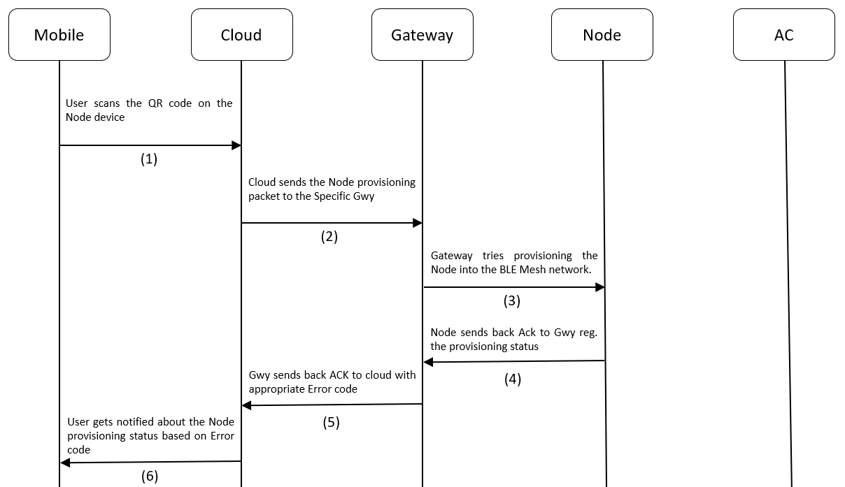

Figure 10.19 Node Provisioning Flow

Node Provision ACK
Description: This ACK is used by cloud to know whether the Node provisioning was successful or not.
Note: In this ACK, the ElementAddr is a very important field, whose value should be noted for further Node operations. Ony using this ElementAddr, the Gateway will be able to communicate with the Node. This ElementAddr field will be included in all Node related MQTT packets.

Node Provisioning ACK JSON (Node to Gateway to Cloud):
{ |  |  |  |  | Range
 | “JsonPacketId” | : | 100 | // (Number)
 | “JsonAckName” | : | “Node Provisioning ACK” | // (String)
 | “MsgSeqNo” | : | 12 | // (Number)
 | “GwySerNo” | : | “GWY00001” | // (String)
 | “NodeSerNo: | : | “N00001” | // (String)
 | “MacId” | : | “D3:F5:FB:CA:14:25” | // (String) (MacID of the Node)
 | “ElementAddr” | : | 23 | // (Number) | [2 - 65535]
 | “Location” | : | “1st Floor” | // (String)
 | “AppKeyIndex” | : | 1 | // (Number)
 | “AppKey” | : | 29 | // (Number)
 | “NetKeyIndex” | : | 5 | // (Number)
 | “NetKey” | : | 37 | // (Number)
 | “ErrorCode” | : | 0 | // (Number)
}

Link To Error Code Reference: Error Codes
Process flow:



Figure 10.20 Node Provisioning ACK Flow

Node AC Remote Configuration ACK
Description: This is an ACK sent by Node to Gwy to Cloud when the Node is successfully configured with an AC remote. When the Node is in AC Remote Configuration mode and AC remote is pressed in-front of the IR receiver in the Node, it will get configured to act as that AC remote from there on.

LED Indication: If the Node has not been AC Remote configured, the Node will glow Solid BLUE LED.

Node Configuration ACK JSON (Node to Gateway to Cloud):
{ |  |  |  |  | Range
 | “JsonPacketId” | : | 101 | // (Number)
 | “JsonAckName” | : | “Node AC Remote Configuration ACK” | // (String)
 | “GwySerNo” | : | “GWY00001” | // (String)
 | “NodeSerNo: | : | “N00001” | // (String)
 | “ElementAddr” | : | 23 | // (Number) | [2 - 65535]
 | “ErrorCode” | : | 0 | // (Number)
}

Link To Error Code Reference: Error Codes

Process flow:

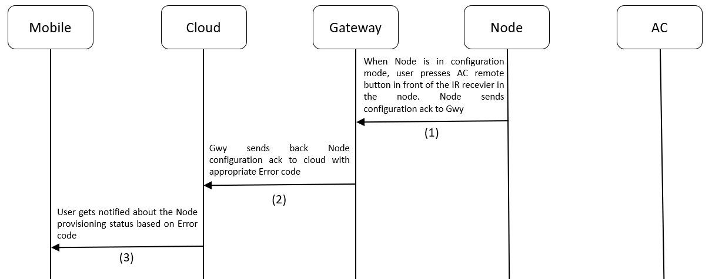

Figure 10.21 Node Configuration Process flow

Node Unprovision Packet
Description: This packet is used to remove a Node device from the BLE Mesh network.

Led Indication: After successful Unprovisioning, Node will start Blinking RED + BLUE.

Node Unprovisioning JSON (Cloud to Gateway to Node):
{ |  |  |  |  | Range
 | “JsonPacketId” | : | 102 | // (Number)
 | “MsgSeqNo” | : | 12 | // (Number)
 | “GwySerNo” | : | “GWY00001” | // (String)
 | “NodeSerNo: | : | “N00001” | // (String)
 | “ElementAddr” | : | 23 | // (Number) | [2 - 65535]
 | “Location” | : | “1st Floor” | // (String) | [30 chars long]
}

Process flow:

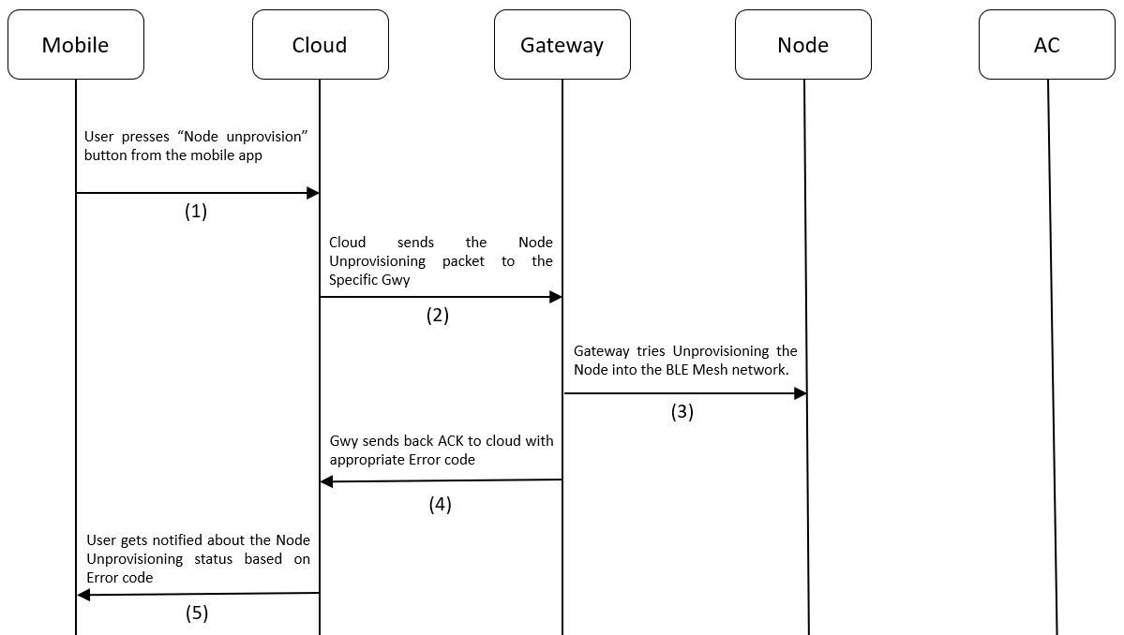

Figure 10.22 Node Unprovsioning Process flow

Node Unprovision ACK
Description: This packet is used to add a Node device into the BLE Mesh network

Node Unprovisioning ACK JSON (Node to Gateway to Cloud):
{
 | “JsonPacketId” | : | 102 | // (Number)
 | “JsonAckName” | : | “Node Unprovisioning ACK” | // (String)
 | “MsgSeqNo” | : | 12 | // (Number)
 | “GwySerNo” | : | “GWY00001” | // (String)
 | “NodeSerNo: | : | “N00001” | // (String)
 | “ElementAddr” | : | 23 | // (Number)
 | “Location” | : | “1st Floor” | // (String)
 | “ErrorCode” | : | 0 | // (Number)
}

Link To Error Code Reference: Error Codes

Process flow:



Figure 10.23 Node Unprovisioning Process flow

Node AC Control Packet
Description: This packet is used to control an AC using the Node. The below table describes the AC control parameters that go with the Node AC Control Packet.

Table 10.5 AC Control Parameters
Sl. No | Parameter | Description
1 | Power | 1 = ON, 0 = OFF
2 | Mode | The following modes are supported: [Cool, Dry, Hot, Fan, auto].
3 | FanSpeed | [1 - 5] levels
3 | Temperature | Sets the AC temperature. Must be between 18 and 32.
4 | SwingH | 1 = ON, 0 = OFF
5 | SwingV | 1 = ON, 0 = OFF
6 | OnTimer | Sets the number of hours past midnight after which AC needs to be turned on automatically. [0 – 12]
7 | OffTimer | Sets the number of hours past midnight after which AC needs to be turned off automatically [0 – 12]
8 | Locking | 1 = ON, 0 = OFF. When ON, if AC was controlled manually, then Node Manual AC Control ACK will be sent to Cloud. Also, when ON, the AC will be maintained between the TempLockUpLimit and TempLockLowLimit. If by manual control, AC temp was set exceeding the above limits, then Node will emit IR Signal to control the AC and bring it back to whatever setting was set by Node lastly.
9 | TempLockUpLimit | Specifies upper temperature locking limit. This parameter will have no effect application wise, when Locking is not enabled. Must have values within the absolute Temperature limits: 18 - 32.
10 | TempLockLowLimit | Specifies Lower temperature locking limit. When Locking is not enabled, this parameter will have no effect application wise. Must have values within the absolute Temperature limits: 18 - 32.

Note: Node Manual AC control ACK is applicable only when devices have not undergone the Teaching Mode Process. For Devices, using the Teaching Mode to control ACs, Node Manual AC control ACK will be sent with all the AC parameter values set to 0. Example ACK for both the cases is provided in the Node Manual AC control ACK section.

Node AC Control JSON (Cloud to Gateway to Node):
{ |  |  |  |  | Range
 | “JsonPacketId” | : | 103 | // (Number)
 | “MsgSeqNo” | : | 12 | // (Number) | [0 - 65535]
 | “GwySerNo” | : | “GWY00001” | // (String) | [00001 - 99999]
 | “NodeSerNo” | : | “N00001” | // (String) | [00001 - 99999]
 | “ElementAddr” | : | 23 | // (Number) | [2 - 65535]
 | “Power” | : | 1 | // (Number) | [0 = OFF, 1 = ON]
 | “Mode” | : | “Cool” | // (String) | [“Cool“, “Dry“, “Auto“, “Fan“, “Hot“]
 | “FanSpeed” | : | 1 | // (Number) | [1 - 5] levels
 | “Temperature” | : | 25 | // (Number) | [18 - 32]
 | “SwingH” | : | 1 | // (Number) | [0 = OFF, 1 = ON]
 | “SwingV” | : | 1 | // (Number) | [0 = OFF, 1 = ON]
 | “OnTimer” | : | 0 | // (Number) | [0 - 12]
 | “OffTimer” | : | 0 | // (Number) | [0 - 12]
 | “Locking” | : | 1 | // (Number) | [0 = OFF, 1 = ON]
 | “TempLockUpLimit” | : | 26 | // (Number) | [18 - 32]
 | “TempLockLowLimit” | : | 20 | // (Number) | [18 - 32]
}

Process flow:

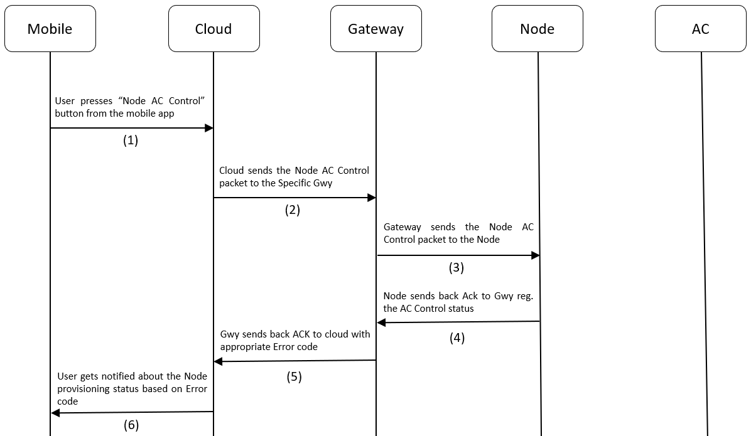

Figure 10.24 Node AC Control Process flow

Node AC Control ACK
Description: This is used by cloud to know if the AC Control was successful or not.
Node AC Control ACK JSON (Node to Gateway to Cloud):
{
 | “JsonPacketId” | : | 103 | // (Number)
 | “JsonAckName” | : | “Node AC Control ACK” | // (String)
 | “MsgSeqNo” | : | 12 | // (Number)
 | “GwySerNo” | : | “GWY00001” | // (String)
 | “NodeSerNo” | : | “N00001” | // (String)
 | “ElementAddr” | : | 23 | // (Number)
 | “Power” | : | 1 | // (Number)
 | “Mode” | : | “Cool” | // (String)
 | “FanSpeed” | : | 1 | // (Number)
 | “Temperature” | : | 25 | // (Number)
 | “SwingH” | : | 1 | // (Number)
 | “SwingV” | : | 1 | // (Number)
 | “OnTimer” | : | 0 | // (Number)
 | “OffTimer” | : | 0 | // (Number)
 | “Locking” | : | 1 | // (Number)
 | “TempLockUpLimit” | : | 26 | // (Number)
 | “TempLockLowLimit” | : | 20 | // (Number)
 | “ErrorCode” | : | 0 | // (Number)
}
Link To Error Code Reference: Error Codes
Process flow:
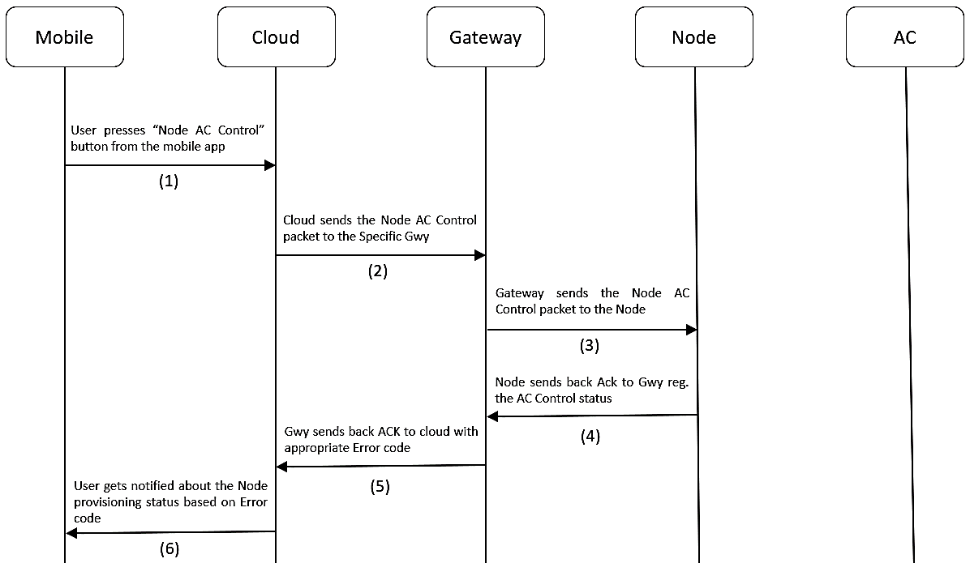

Figure 10.25 Node AC Control Process flow

Node AC Manual control ACK
Description: If Locking was enabled, this ACK is used by cloud to know whether the AC was controlled manually using the AC remote. If someone controls the AC manually using the remote, then the IR receiver on-board will capture this IR signal and decode it. If it’s a signal from the same remote with which the Node was configured during the AC Remote configuration process, then it will store the manual control information for sending it to the cloud. Also, it performs logical operation based on the temperature that was set using the remote. If it exceeds the Locking temperature limits set from the Node AC Control packet, then it will bring the AC’s temperature back to permissible limits.
Note: The Node Manual Control ACK will work only for Devices that are not using Teaching Mode to control AC.

Node AC Manual Control ACK JSON (Node to Gateway to Cloud) (Non-Teaching Mode case):

{
 | “JsonPacketId” | : | 104 | // (Number)
 | “JsonAckName” | : | “Node AC Manual Control ACK” | // (String)
 | “GwySerNo” | : | “GWY00001” | // (String)
 | “NodeSerNo: | : | “N00001” | // (String)
 | “ElementAddr” | : | 23 | // (Number)
 | “Power” | : | 1 | // (Number)
 | “Mode” | : | “Cool” | // (String)
 | “FanSpeed” | : | 1 | // (Number)
 | “Temperature” | : | 25 | // (Number)
}

Node AC Manual Control ACK JSON (Node to Gateway to Cloud) (Teaching Mode case):

{
 | “JsonPacketId” | : | 104 | // (Number)
 | “JsonAckName” | : | “Node Manual AC Control ACK” | // (String)
 | “GwySerNo” | : | “GWY00001” | // (String)
 | “NodeSerNo: | : | “N00001” | // (String)
 | “ElementAddr” | : | 23 | // (Number)
 | “Power” | : | 0 | // (Number)
 | “Mode” | : | “” | // (String)
 | “FanSpeed” | : | 0 | // (Number)
 | “Temperature” | : | 0 | // (Number)
}

Process flow:

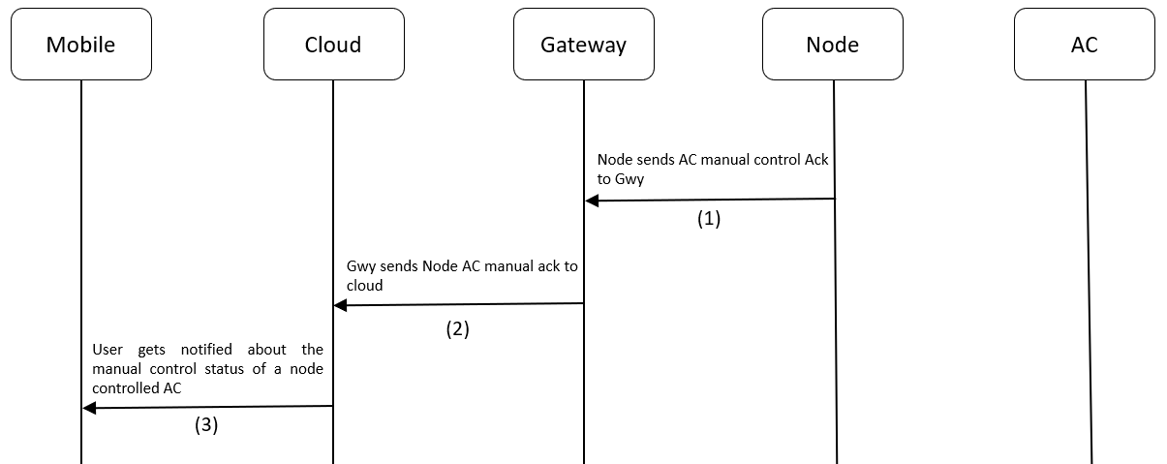

Figure 10.26 Node AC Locking Process flow

Node AC Remote Reconfiguration Packet
Description: This packet is used to reset the MQTT parameters saved in the Gateway. This puts the Node into AC Remote Configuration mode.

LED Indication: Node will glow Solid BLUE to indicate the Node has entered AC Remote Configuration mode

Node AC Remote Reconfiguration JSON (Cloud to Gateway to Node):
{ |  |  |  |  | Range
 | “JsonPacketId” | : | 105 | // (Number)
 | “MsgSeqNo” | : | 12 | // (Number) | [0 – 65535]
 | “GwySerNo” | : | “GWY00001” | // (String) | [00000 - 99999]
 | “NodeSerNo: | : | “N00001” | // (String)
 | “ElementAddr” | : | 23 | // (Number)
}

Process flow:

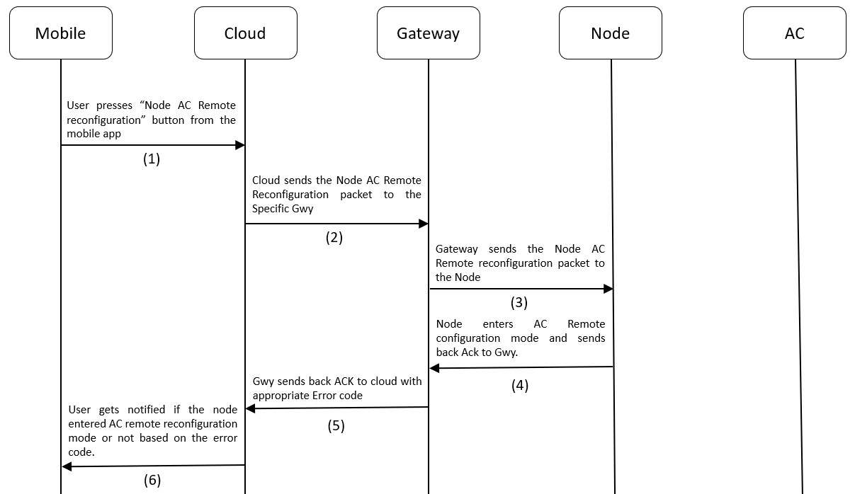

Figure 10.27 Node Reconfiguration Process flow

Node AC Remote Reconfiguration ACK
Description: This ACK is used by cloud to know whether the node successfully entered AC Remote configuration mode or not, after receiving the Node AC Remote Reconfiguration Packet.

LED Indication: Node will glow Solid BLUE to indicate the Node has entered AC Remote Configuration mode

Node Reconfiguration ACK JSON (Node to Gateway to Cloud):
{ |  |  |  |  | Range
 | “JsonPacketId” | : | 105 | // (Number)
 | “JsonAckName” | : | “Node AC Remote Reconfiguration ACK” | // (String)
 | “MsgSeqNo” | : | 12 | // (Number)
 | “GwySerNo” | : | “GWY00001” | // (String)
 | “NodeSerNo: | : | “N00001” | // (String)
 | “ElementAddr” | : | 23 | // (Number) | [2 - 65535]
 | “ErrorCode” | : | 0 | // (Number)
}

Link To Error Code Reference: Error Codes

Process flow:



Figure 10.28 Node Reconfiguration Process flow

Node Heartbeat ACK
Description: This ACK is used by cloud to know the ambient temperature of the environment in which the Node is operating. This ACK is sent periodically to the Gwy to Cloud. This frequency can be configured in the Node Heartbeat Publish Configuration Packet
Node Heartbeat ACK JSON (Node to Gateway to Cloud):
{
 | “JsonPacketId” | : | 106 | // (Number)
 | “JsonAckName” | : | “Node Heartbeat ACK” | // (String)
 | “GwySerNo” | : | “GWY00001” | // (String)
 | “NodeSerNo: | : | “N00001” | // (String)
 | “ElementAddr” | : | 23 | // (Number)
 | “Power” | : | 1 | // (Number)
 | “Mode” | : | “Cool” | // (String)
 | “FanSpeed” | : | 3 | // (Number)
 | “Temperature” | : | 25 | // (Number)
 | “AmbientTemperature” | : | 23 | // (Number)
 | “SwingH” | : | 1 | // (Number)
 | “SwingV” | : | 0 | // (Number)
 | “OnTimer” | : | 5 | // (Number)
 | “OffTimer” | : | 12 | // (Number)
 | “Locking” | : | 0 | // (Number)
 | “TempLockUpLimit” | : | 27 | // (Number)
 | “TempLockLowLimit” | : | 20 | // (Number)
}

Process flow:

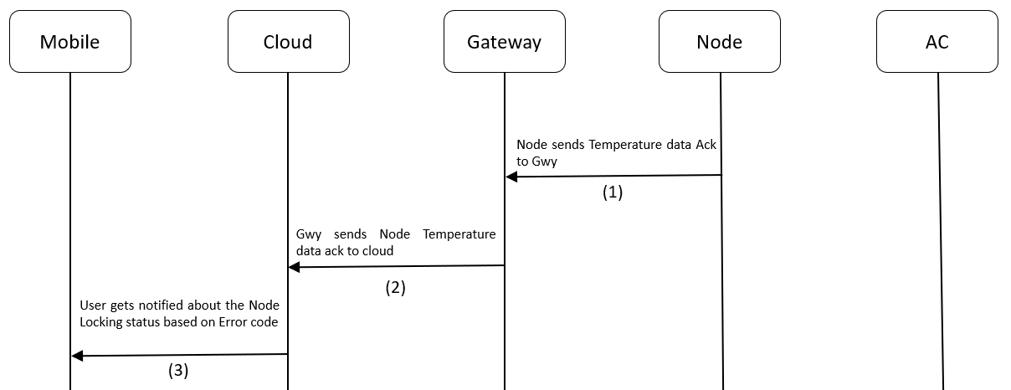

Figure 10.29 Node Heartbeat Process flow

Node Heartbeat Publish Configuration Packet
Description: This packet is used to tell the Node, how frequently It needs to send Heartbeat ACK to Gwy, so that Gwy can send it to Cloud. This frequency is configurable in seconds. The default value is 10s.

Node Temperature Publish Configuration JSON (Cloud to Gateway):
{ |  |  |  |  | Range
 | “JsonPacketId” | : | 107 | // (Number)
 | “MsgSeqNo” | : | 12 | // (Number) | [0 – 65535]
 | “GwySerNo” | : | “GWY00001” | // (String) | [00001 - 99999]
 | “NodeSerNo” | : | “N00001” | // (String) | [00001 - 99999]
 | “ElementAddr” | : | 23 | // (Number) | [2 - 65535]
 | “PublishPeriodSec” | : | 15 | // (Number) (in sec) | [300 - 65535]
}

Process flow:

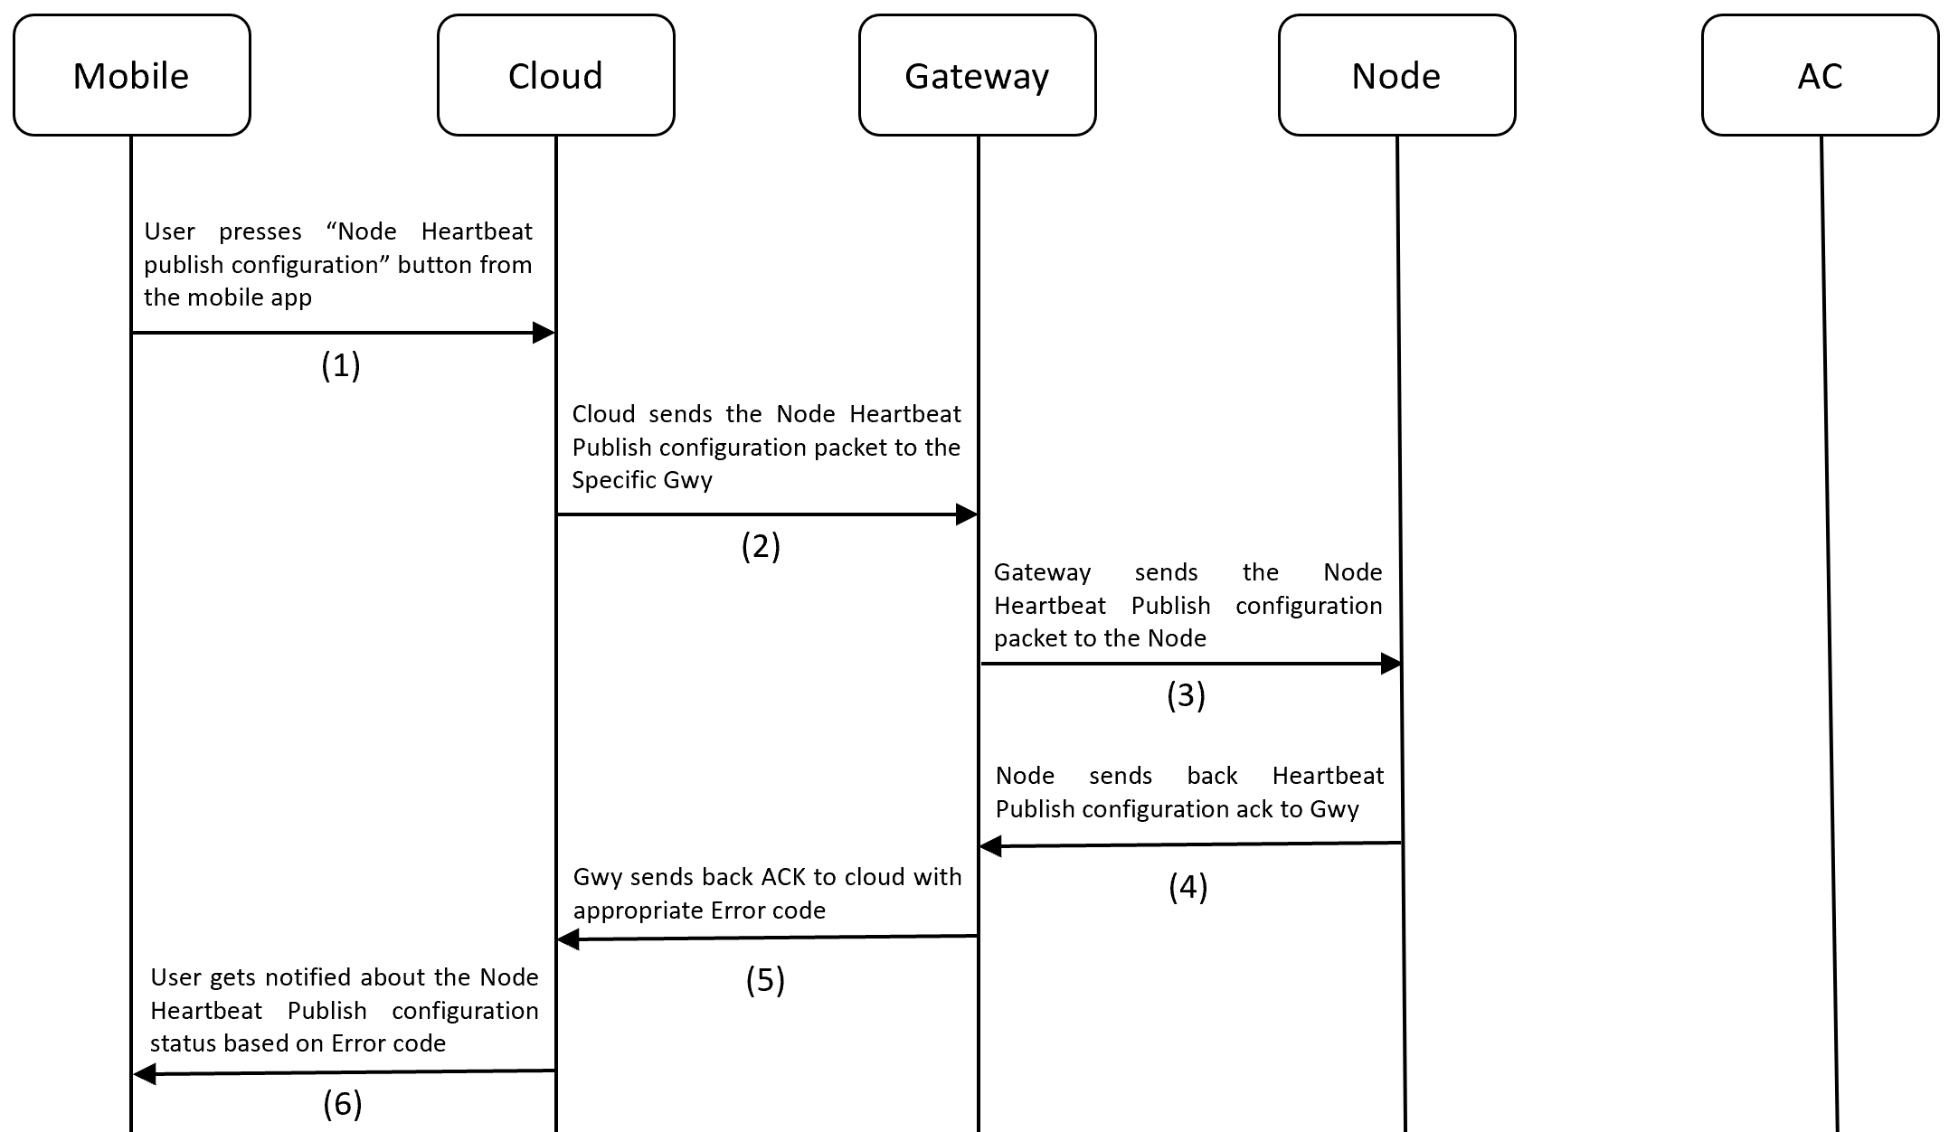

Figure 10.30 Node Publish Configuration process flow

Node Heartbeat Publish Configuration ACK
Description: This ACK is used by cloud to know if the Node publish configuration was successful or not.

Node Publish Configuration ACK JSON (Node to Gateway to Cloud):
{ |  |  |  |  | Range
 | “JsonPacketId” | : | 107 | (Number)
 | “JsonAckName” | : | “Node Heartbeat Publish Configuration ACK” | (String)
 | “MsgSeqNo” | : | 12 | (Number)
 | “GwySerNo” | : | “GWY00001” | (String)
 | “NodeSerNo” | : | “N00001” | (String)
 | “ElementAddr” | : | 23 | (Number) | [2 - 65535]
 | “PublishPeriodSec” | : | 15 | (Number)
 | “ErrorCode” | : | 0 | (Number)
}

Link To Error Code Reference: Error Codes

Process flow:


Figure 10.31 Node Publish Configuration process flow

Node Teaching Mode Start Packet
Description: This packet is used to make a Node enter Teaching mode.

Led Indication: Node will glow Blinking BLUE to indicate it has entered Teaching mode.

Node Teaching Mode Start JSON (Cloud to Gateway to Node):

{ |  |  |  |  | Range
 | “JsonPacketId” | : | 108 | // (Number)
 | “MsgSeqNo” | : | 12 | // (Number) | [0 – 65535]
 | “GwySerNo” | : | “GWY00001” | // (String) | [00001 - 99999]
 | “NodeSerNo” | : | “N00001” | // (String) | [00001 - 99999]
 | “ElementAddr” | : | 23 | // (Number) | [2 - 65535]
}

Process flow:

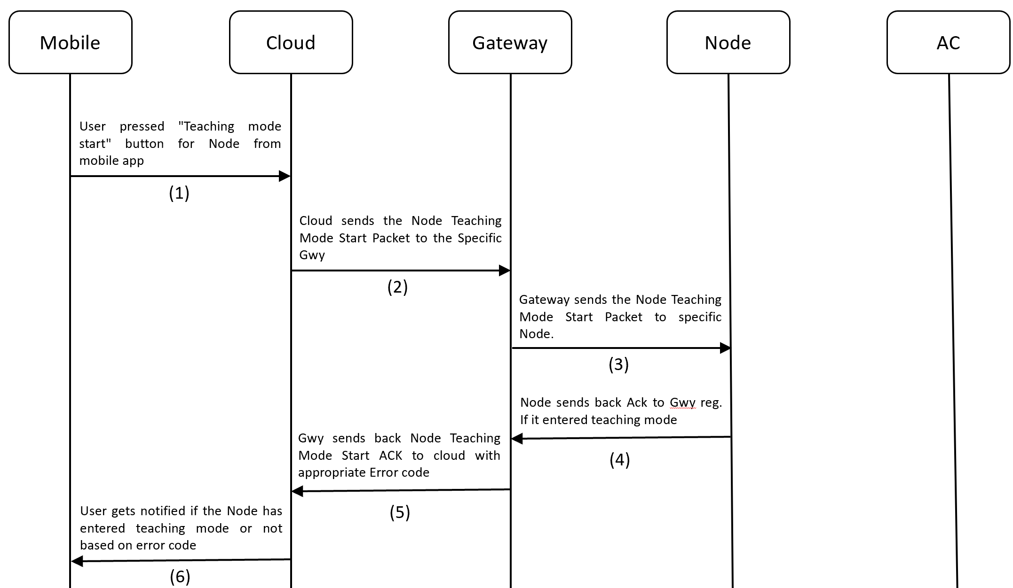

Figure 10.32 Node Teaching Mode Start Flow

Steps to Perform Teaching Mode:
- Make sure Gateway is registered / Make sure Node is provisioned.
- IMPORTANT NOTE (before making the device enter Teaching mode): Take the AC remote and bring down the temperature to 19 and power ON the AC. So that, when you press the power button again, it should send the POWER OFF signal. This is very important in-order to successfully register the commands to EEPROM on-board and complete the teaching process. The sequence of IR signals for teaching mode is as follows:
  - POWER OFF | TEMP 19
  - POWER ON | TEMP 19
  - POWER ON | TEMP 20
  - POWER ON | TEMP 21
  - POWER ON | TEMP 22
  - POWER ON | TEMP 23
  - POWER ON | TEMP 24
  - POWER ON | TEMP 25
  - POWER ON | TEMP 26
  - POWER ON | TEMP 27
  - POWER ON | TEMP 28
- Long press the button for 3s – 8s or use the Gateway Teaching Mode Start Packet to put the device into Teaching Mode. The LED will start Fast Blinking BLUE (once every 200ms) to indicate it has entered teaching mode.
- Press the POWER ON button on the AC remote with remote pointing towards to IR receiver on-board for successful reception and prevent false recording.
- The device will read the IR signal from the remote and store it in flash. While this process is happening, the light will turn off momentarily to indicate that no other buttons on AC remote must be pressed to let the process go on without disturbance. Also, make sure you are doing this process in an IR disturbance free environment. Most smartphones these days use IR emitters, so it's one thing that I experienced during my development.
- Once the LED starts blinking BLUE again, it's time to record the next IR signal. The next signal is POWER ON | TEMP 19.
- Similarly, go one-by-one all the way up to POWER ON | TEMP 28. If everything was done right, then, when the last IR signal was sent, the LED will change to SOLID GREEN to indicate successful completion of the Teaching Mode process
Steps to Exit Teaching Mode:

- When already in Teaching Mode, if the button is long pressed for 3s-8s, device will exit teaching mode.

Node Teaching Mode Start ACK
Description: This ACK is used by the cloud to know if the Node has successfully entered the teaching mode or not after receiving Node Teaching Mode Start Packet.

Led Indication: Node will glow Blinking BLUE to indicate it has entered Teaching mode

Node Teaching Mode start ACK JSON (Node to Gateway to Cloud):

{
 | “JsonPacketId” | : | 108 | // (Number)
 | “JsonAckName” | : | “Node Teaching Mode Start ACK” | // (String)
 | “MsgSeqNo” | : | 12 | // (Number)
 | “GwySerNo” | : | “GWY00001” | // (String)
 | “NodeSerNo” | : | “N00001” | // (String)
 | “ElementAddr” | : | 23 | // (Number)
 | “ErrorCode” | : | 0 | // (Number)
}

Link To Error Code Reference: Error Codes
Process flow:



Figure 10.33 Node Teaching Mode Start ACK flow

Node Teaching Mode End ACK
Description: This ACK is used by the cloud to know if the Node has exited teaching mode. Based on Error code, the user will know whether the teaching process was completed fully or not.

LED Indication: After completing the Teaching process, the LED will change to Solid GREEN.

Node Teaching Mode End ACK JSON (Node to Gateway to Cloud):

{
 | “JsonPacketId” | : | 109 | // (Number)
 | “JsonAckName” | : | “Node Teaching Mode End ACK” | // (String)
 | “GwySerNo” | : | “GWY00001” | // (String)
 | “NodeSerNo” | : | “N00001” | // (String)
 | “ElementAddr” | : | 23 | // (Number)
}

Process flow:

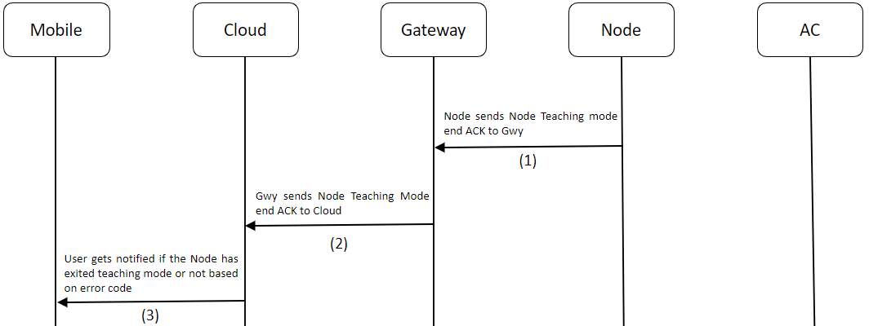

Figure 10.34 Node Teaching Mode End flow

Node Debug Info Packet (Only for QMAX Internal use)
Description: This packet is sent to retrieve information from a Node device regarding the firmware version it’s currently running, AC Remote configuration status, Device Uptime, etc., This packet also contains a parameter called logging, which can be used to enable/disable logging during runtime. Logging can also be enabled/disable by Single pressing the button on the device.

Node Debug Info Packet JSON (Cloud to Gateway to Node):

{ |  |  |  |  | Range
 | “JsonPacketId” | : | 110 | // (Number)
 | “MsgSeqNo” | : | 12 | // (Number) | [0 – 65535]
 | “GwySerNo” | : | “GWY00001” | // (String) | [00001 - 99999]
 | “NodeSerNo” | : | “N00001” | // (String) | [00001 - 99999]
 | “ElementAddr” | : | 23 | // (Number) | [2 - 65535]
 | “Logging” | : | 1 | // (Number) | [0 = OFF, 1 = ON]
 | “ResetDevice” | : | 1 | // (Number) | [0 = False, 1 = True]
}

Process flow:

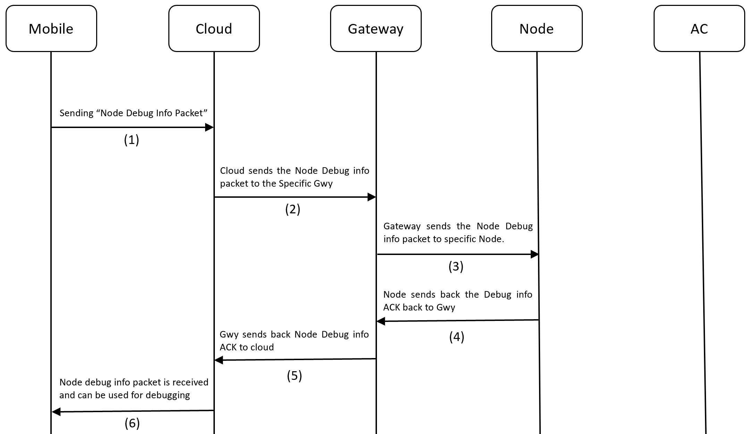

Figure 10.35 Node Debug Info Process Flow

Node Debug Info ACK (Only for QMAX Internal use)
Description: This ACK is used for Debugging purposes.

Node Debug Info Packet ACK JSON (Node to Gateway to Cloud):

{
 | “JsonPacketId” | : | 110 | // (Number)
 | “JsonAckName” | : | “Node Debug Info ACK” | // (String)
 | “MsgSeqNo” | : | 12 | // (Number)
 | “GwySerNo” | : | “GWY00001” | // (String)
 | “NodeSerNo” | : | “N00001” | // (String)
 | “ElementAddr” | : | 23 | // (Number)
 | “FirmwareVersion” | : | “1.1” | // (String) (Maj.Min)
 | “Protocol” | : | DAIKIN216 | // (String)
 | “PublishPeriodSec” | : | 300 | // (Number)
 | “DeviceUpTimeHrs” | : | “0.54” | // (String) (in hrs)
 | “Logging” | : | 1 | // (Number)
 | “ResetDevice” | : | 1 | // (Number)
 | “ErrorCode” | : | 0 | // (Number)
}
Link To Error Code Reference: Error Codes
Process Flow:


Figure 10.36 Node Debug Info ACK flow

~~~~~~~~~~~ End of Document ~~~~~~~~~~~

